

**The Egyptian E-Learning University (EELU)**

**Faculty of Computer & Information Technology**

**" A machine learning –based recommender system for E-Commerce "**

**BY:**

|  |  |  |
| --- | --- | --- |
| **No.** | **Name** | **ID** |
| **1** | Mahmoud Mahmoud Saad Mohamed Qasim | 1900531 |
| **2** | AbdElRahman Hosni AbdElAziz Sayed | 2001008 |
| **3** | Ali Mohamed Abd ElRahman Ahmed Idris | 1900573 |
| **4** | Shady Mamdouh Shousha Boules | 2000798 |
| **5** | Andrew Ebrahim Saad Saeid | 2000504 |
| **6** | Amar ElHosseny Salah Mahmoud ElSalamty | 1900276 |
| **7** | Mostafa Mohamed Mostafa Youssf | 1900216 |
| **8** | Mohamed Ashraf Abdelaziz | 1900167 |
|  |  |  |

**Under Supervision of:**

|  |  |
| --- | --- |
| **Dr.Ahmed Yacoub** | **Eng. Marihan Raafat** |
| - prof of Computer Science and Information Technology  Egyptian E-Learning University | - Teaching Assistant in Computer and Information Technology  Egyptian E-Learning University |

"This documentation is provided as a partial fulfillment of the requirements for the degree of Bachelor of Science in Computer & Information Technology"

**EELU Ain shams- 2024**

All Praises and Thanks Be to Allah for the success and his help for us to finish the project this year.

During this year we had to take advice and support from a boom of respectable people and we had to thank them for their time and effort and we would like to express our gratitude and thanks to them and we would like to show this to our supervisors:

1. **Dr**. **Ahmed Yacoub**
2. Prof of Computer Science and Information Technology

Egyptian E-Learning University)

1. **Eng. Marihan Raafat**

(Teaching Assistant in Computer and Information Technology faculty At Egyptian E Learning University)

For giving us a good guideline for the Project throughout numerous consultations. We would also like to expand our deepest gratitude to all those who have directly and indirectly guided us in doing this Project.

Many people, especially our classmates and team members itself, have made valuable comment suggestions on this proposal which gave us an inspiration to improve our project. We thank all the people for their help directly and indirectly to complete our project.

Chapter 1: Introduction ............................................................................................. 4

1.1 Introduction ..................................................................................................... 4

1.2 Problem definition ........................................................................................... 6

1.3 Project objective ............................................................................................ 9

1.4 Motivation ..................................................................................................... 13

1.5 System Architecture ...................................................................................... 17

1.6 Related Work ................................................................................................. 21

Chapter 2: Methodologies and Techniques ............................................................ 24

2.1 What is Adobe XD? ....................................................................................... 29

2.1.1 What is adobe XD used for? ............................................................. 29

2.1.2 Adobe XD features ........................................................................... 29

2.2 What is front end? .......................................................................................... 31

**Components of Front End Development**: - .............................................. 31

1. HTML ....................................................................31

2.CSS......................................................................... 37

2.JavaScript.............................................................. 48

3.JQuery……………………………………………………………….52

2.3 What is the Backend? .................................................................................... 56

2.3.1 Reasons for using the backend:- ....................................................... 56

2.3.2 Backend Types and Their Use Cases ................................................ 57

2.2.3 The technique we used in the backend ............................................ 59

1.PHP……………………………………………………...59

3.3MySQL Database……………………………………………………………………….74

2.3.3.2 Firebase History .................................................................. 78

2.3.3.3 Popular Apps Using Firebase ............................................. 79

2.3.3.4 Firebase use cases ................................................................ 79

2.3.3.5 Firebase Limitations ............................................................ 80

Chapter 3: Implementation and Coding ................................................................. 81

3.1: Software Techniques ..................................................................................... 82

3.2: Analyzing the system .................................................................................... 83

Chapter 4: Summary, Conclusions and Future Work ..........................................89

4.1 Summary .....................................................................................................90

4.2 Conclusion ................................................................................................... 93

4.3 Challenges ................................................................................................... 96

**1. Introduction**

**Welcome to [E-commerce Shopping]**

Welcome to the comprehensive documentation for **E-commerce Shopping** , an innovative and robust e-commerce platform designed to facilitate seamless online product sales using PHP. This documentation serves as an all-encompassing guide, offering insights into the website’s architecture, detailed feature descriptions, user instructions, and technical setup processes. Whether you are a developer looking to understand the backend intricacies, an administrator managing the store, or an end-user exploring its functionalities, this documentation aims to provide clear and concise information to help you navigate and utilize the platform effectively. In today’s digital age, having a reliable and user-friendly e-commerce platform is crucial for businesses looking to expand their reach and drive sales online. **E-commarce Shopping**

## 1.2 Problem Definition

In the rapidly evolving digital marketplace, businesses face numerous challenges when it comes to establishing a strong online presence and managing their e-commerce operations. The primary problems that [Your Website Name] aims to address are:

### 1. Fragmented Online Presence

Many businesses struggle to create a cohesive and professional online storefront that accurately reflects their brand identity. This fragmentation often leads to a poor user experience, deterring potential customers and resulting in lost sales.

### 2. Inefficient Product Management

Managing a large inventory of products, updating listings, and ensuring accurate product information can be time-consuming and error-prone. Without an efficient system in place, businesses may find it challenging to keep their online store updated, leading to inconsistencies and customer dissatisfaction.

### 3. Complicated Checkout Processes

A complicated or lengthy checkout process can lead to cart abandonment and lost sales. Customers expect a seamless, quick, and secure checkout experience. Without streamlined payment integration and a user-friendly interface, businesses risk losing potential customers at the final step of the purchase process.

### 4. Limited Order Tracking and Management

Both customers and administrators need effective tools to track and manage orders. Customers expect real-time updates on their order status, while administrators require comprehensive systems to process, fulfill, and manage orders efficiently. Limited order tracking capabilities can lead to customer dissatisfaction and operational inefficiencies.

### 5. Security Concerns

In the e-commerce industry, security is paramount. Businesses must ensure that customer data, including personal and payment information, is protected against breaches and fraud. A lack of robust security measures can result in data breaches, loss of customer trust, and significant financial and reputational damage.

### 6. Scalability Issues

As businesses grow, their e-commerce platform must be able to scale to accommodate increased traffic, a larger product catalog, and more complex operations. Many existing solutions fail to scale effectively, leading to performance issues, downtime, and a poor user experience.

### 7. Administrative Burden

Administrators often face a significant burden in managing the day-to-day operations of an e-commerce store. This includes updating product listings, handling customer inquiries, processing orders, and generating reports. Without an efficient administrative interface, these tasks can become overwhelming and hinder business growth.

### 8. Integration Challenges

Businesses often use multiple systems and tools to manage their operations, including CRM software, accounting systems, and marketing platforms. Integrating these systems with their e-commerce platform can be challenging, leading to data silos and inefficiencies.

### Addressing the Problems with E-commarce shopping

E-commarce shopping is designed to address these challenges by providing a comprehensive, user-friendly, and scalable e-commerce solution:

* **Unified Online Presence**: Offering a cohesive and professional online storefront that enhances brand identity and user experience.
* **Efficient Product Management**: Simplifying the process of managing and updating product listings, ensuring accuracy and consistency.
* **Streamlined Checkout Process**: Providing a quick, secure, and user-friendly checkout experience to reduce cart abandonment rates.
* **Advanced Order Tracking**: Equipping both customers and administrators with tools to track and manage orders efficiently.
* **Robust Security**: Implementing strong security measures to protect customer data and build trust.
* **Scalability**: Ensuring the platform can grow with the business, handling increased traffic and a larger product catalog.
* **Efficient Administrative Interface**: Reducing the burden on administrators by providing intuitive tools for managing the store.
* **Seamless Integration**: Facilitating the integration with various systems and tools to streamline business operations.

**1.3 Project Objective**

The primary objective of e-commarce shopping is to develop a robust, scalable, and user-friendly e-commerce platform that meets the diverse needs of businesses and their customers. This platform is designed to streamline the process of online selling, enhance the shopping experience, and provide powerful management tools for administrators. The following objectives outline the key goals of the project:

**1. Enhance User Experience**

* **Intuitive Navigation**: Design a user interface that is easy to navigate, allowing customers to find products quickly and effortlessly.
* **Responsive Design**: Ensure the platform is fully responsive, providing a seamless experience across various devices, including desktops, tablets, and smartphones.
* **Personalized Shopping Experience**: Implement features such as personalized recommendations, wish lists, and user reviews to enhance the shopping experience.

**2. Simplify Product Management**

* **Comprehensive Product Catalog**: Develop a system that allows administrators to easily add, update, and categorize products, ensuring the product catalog is always up-to-date and well-organized.
* **Advanced Search and Filter Options**: Provide customers with powerful search and filter options to help them find products based on specific criteria quickly.

**3. Streamline the Checkout Process**

* **Secure and Efficient Checkout**: Create a streamlined checkout process that minimizes steps and ensures secure transactions, reducing cart abandonment rates.
* **Multiple Payment Gateway Integration**: Integrate with various payment gateways such as PayPal and Stripe to offer customers multiple payment options.

**4. Improve Order Management**

* **Real-Time Order Tracking**: Implement real-time order tracking capabilities for customers to monitor the status of their orders from placement to delivery.
* **Efficient Order Processing**: Develop tools for administrators to efficiently process, fulfill, and manage orders, reducing processing time and errors.

**5. Ensure Robust Security**

* **Data Protection**: Implement strong security measures to protect customer data, including encryption, secure authentication, and compliance with data protection regulations.
* **Fraud Prevention**: Integrate tools and features to detect and prevent fraudulent activities, ensuring a safe shopping environment.

**6. Scalability and Performance**

* **Scalable Infrastructure**: Build the platform on a scalable infrastructure that can handle increasing traffic, a growing product catalog, and more complex operations as the business grows.
* **Performance Optimization**: Ensure the platform is optimized for performance, providing fast load times and smooth interactions even under heavy loads.

**7. Empower Administrators**

* **User-Friendly Admin Panel**: Develop a comprehensive and intuitive admin panel that allows administrators to manage products, orders, users, and site content effectively.
* **Reporting and Analytics**: Provide detailed reports and analytics tools to help administrators make informed decisions based on sales performance, customer behavior, and other key metrics.

**8. Facilitate Seamless Integration**

* **Integration with Third-Party Tools**: Ensure the platform can seamlessly integrate with various third-party tools and systems, including CRM software, accounting systems, and marketing platforms, to streamline business operations and improve efficiency.

**9. Provide Comprehensive Support and Documentation**

* **Detailed Documentation**: Create comprehensive documentation to guide developers, administrators, and users in setting up, managing, and using the platform effectively.
* **Customer Support**: Offer robust customer support options, including a knowledge base, FAQs, and direct support channels, to assist users with any issues or questions they may have.

**Conclusion**

By achieving these objectives, e-commarce shopping aims to provide a powerful and versatile e-commerce platform that not only meets the current needs of businesses and their customers but also adapts and scales to accommodate future growth and technological advancements. Our goal is to deliver a solution that enhances the online shopping experience, simplifies management tasks, and ensures a secure and efficient operation, ultimately contributing to the success of businesses in the digital marketplace.

is built with the purpose of providing businesses with a powerful tool to manage their online presence and sales operations efficiently. Our vision is to empower businesses of all sizes by offering a scalable and customizable platform that meets their unique needs, ensuring they can provide a superior shopping experience to their customers.

**1.4 Motivation**

**Understanding the Need for a Robust E-commerce Platform**

In today's fast-paced digital world, the significance of an effective e-commerce platform cannot be overstated. The motivation behind developing [Your Website Name] stems from recognizing the critical role that a well-designed online store plays in the success of modern businesses. Here are the key motivational factors driving this project:

**1. Responding to Market Trends**

* **E-commerce Growth**: The global e-commerce market has been experiencing exponential growth, with more consumers turning to online shopping for convenience, variety, and competitive pricing. This trend has created a demand for reliable and scalable e-commerce solutions that can handle increasing traffic and sales volumes.
* **Consumer Expectations**: Modern consumers expect a seamless and personalized shopping experience. They demand quick access to products, intuitive navigation, secure transactions, and efficient customer support. Meeting these expectations requires a sophisticated platform that integrates the latest technologies and best practices.

**2. Supporting Small and Medium-sized Enterprises (SMEs)**

* **Leveling the Playing Field**: SMEs often face challenges competing with larger corporations that have significant resources to invest in their online presence. [Your Website Name] aims to level the playing field by providing an affordable, yet powerful e-commerce solution that enables SMEs to build and manage professional online stores.
* **Business Growth**: By offering a scalable platform, [Your Website Name] helps SMEs grow their businesses without being constrained by technological limitations. The platform’s features and tools support business expansion, enabling SMEs to reach a broader audience and increase their sales.

**3. Enhancing Operational Efficiency**

* **Automating Processes**: Many businesses struggle with the manual tasks associated with managing an online store, such as inventory management, order processing, and customer communication. [Your Website Name] seeks to automate these processes, reducing the administrative burden and allowing businesses to focus on strategic growth.
* **Data-Driven Decisions**: Providing comprehensive analytics and reporting tools empowers businesses to make informed decisions based on real-time data. This insight helps businesses optimize their operations, improve customer satisfaction, and increase profitability.

**4. Ensuring Security and Compliance**

* **Protecting Customer Data**: With the rise in cyber threats, ensuring the security of customer data is paramount. [Your Website Name] is motivated by the need to provide a secure shopping environment that protects sensitive information and builds customer trust.
* **Regulatory Compliance**: Adhering to data protection regulations such as GDPR (General Data Protection Regulation) is crucial for any e-commerce platform. [Your Website Name] is designed to ensure compliance with these regulations, helping businesses avoid legal issues and penalties.

**5. Facilitating Innovation and Customization**

* **Adapting to Business Needs**: Every business has unique needs and goals. [Your Website Name] is motivated by the desire to offer a customizable platform that can be tailored to fit specific business requirements. This flexibility allows businesses to innovate and differentiate themselves in the competitive e-commerce landscape.
* **Encouraging Technological Adoption**: By integrating the latest technologies, such as AI-driven recommendations, chatbots for customer support, and advanced search algorithms, [Your Website Name] encourages businesses to adopt innovative solutions that enhance their operations and customer experience.

**6. Providing Comprehensive Support**

* **Guiding New Entrepreneurs**: Many new entrepreneurs are venturing into the e-commerce space without prior experience. [Your Website Name] is motivated to provide detailed documentation, tutorials, and customer support to help these entrepreneurs successfully set up and manage their online stores.
* **Community and Collaboration**: Building a community around the platform where users can share insights, solutions, and best practices is another motivational factor. This collaborative environment fosters continuous improvement and innovation.

**Conclusion**

The motivation behind e-commarce shopping is rooted in the desire to address the challenges faced by modern businesses in the e-commerce landscape. By providing a robust, secure, and customizable platform, we aim to empower businesses to thrive in the digital marketplace. Our commitment to enhancing user experience, supporting business growth, ensuring security, and fostering innovation drives us to deliver a solution that meets the evolving needs of our users. Through e-commarce shopping, we strive to make e-commerce accessible, efficient, and successful for businesses of all sizes.

**1.5 System Architecture**

The system architecture of ecommerce shopping is carefully designed to ensure scalability, reliability, and performance while providing a seamless user experience for both customers and administrators. This section outlines the key components and their interactions within the system:

**1. Frontend**

* **HTML, CSS, JavaScript**: The frontend of ecommerce shopping is built using standard web technologies including HTML for structure, CSS for styling, and JavaScript for interactivity.
* **Responsive Design**: The frontend is designed to be fully responsive, adapting to various screen sizes and devices to provide a consistent user experience across desktops, tablets, and smartphones.
* **Dynamic Content Rendering**: JavaScript frameworks like React or Vue.js may be employed to render dynamic content and enhance the user interface.

**2. Backend**

* **PHP**: The core backend of ecommerce shopping is powered by PHP, a server-side scripting language known for its flexibility, performance, and extensive ecosystem of libraries and frameworks.
* **Model-View-Controller (MVC) Architecture**: ecommerce shopping follows the MVC architectural pattern, separating the application into three interconnected components:
  + **Model**: Responsible for managing data and business logic, interacting with the database.
  + **View**: Handles the presentation layer, rendering the user interface.
  + **Controller**: Acts as an intermediary between the Model and View, processing requests, and coordinating the flow of data.

**3. Database**

* **MySQL**: ecommerce shopping uses MySQL, a popular relational database management system, to store and retrieve data related to products, orders, users, and other entities.
* **Normalization and Indexing**: The database is designed with normalization to eliminate redundancy and indexing to optimize query performance, ensuring efficient data storage and retrieval.

**4. Web Server**

* **Apache**: Apache HTTP Server is used as the web server software to handle incoming HTTP requests and serve web pages to users.
* **Load Balancing (Optional)**: For high-traffic websites, load balancing techniques may be implemented to distribute incoming traffic across multiple web servers, ensuring optimal performance and reliability.

**5. Payment Gateway Integration**

* **PayPal, Stripe, etc.**: ecommerce shopping integrates with popular payment gateways such as PayPal and Stripe to facilitate secure online transactions. These payment gateways handle payment processing, ensuring that customer payment information is encrypted and secure.

**6. Administrative Interface**

* **Admin Panel**: ecommerce shopping includes an intuitive admin panel that allows administrators to manage product listings, orders, customers, and other aspects of the e-commerce platform.
* **Authentication and Authorization**: The admin panel implements robust authentication and authorization mechanisms to ensure that only authorized users can access and perform administrative tasks.

**7. Third-Party Integrations**

* **CRM Systems, ERP Software, etc.**: ecommerce shopping may integrate with third-party systems such as Customer Relationship Management (CRM) software, Enterprise Resource Planning (ERP) systems, and marketing automation platforms to streamline business operations and data management.

**8. Security Measures**

* **Data Encryption**: Sensitive data, such as user passwords and payment information, is encrypted using industry-standard encryption algorithms to protect it from unauthorized access.
* **Firewalls and Intrusion Detection Systems (IDS)**: Firewalls and IDS are implemented to monitor and prevent unauthorized access and malicious activities on the server.

**9. Scalability and Performance Optimization**

* **Caching**: Caching techniques may be employed to cache frequently accessed data and improve response times, reducing server load and enhancing performance.
* **Horizontal and Vertical Scaling**: ecommerce shopping is designed to scale horizontally by adding more web servers or vertically by upgrading hardware resources to handle increasing traffic and workload.

**Conclusion**

The system architecture of ecommerce shopping is built to deliver a robust, scalable, and secure e-commerce platform that meets the needs of modern businesses and their customers. By employing industry best practices and leveraging proven technologies, ecommerce shopping provides a reliable foundation for businesses to establish and grow their online presence. With a focus on performance, security, and flexibility, ecommerce shopping is well-equipped to adapt to evolving business requirements and technological advancements in the ever-changing e-commerce landscape.

**1.6 Related Work**

In the realm of e-commerce platforms, several existing solutions and frameworks serve as benchmarks and sources of inspiration for the development of [Your Website Name]. This section highlights some of the notable related works and their key features:

**1. Magento**

* **Scalability**: Magento is renowned for its scalability, capable of handling large catalogs and high traffic volumes effectively.
* **Customization**: Offers extensive customization options, allowing businesses to tailor their online stores to meet specific requirements.
* **Community and Enterprise Editions**: Provides both community and enterprise editions, catering to businesses of all sizes.

**2. WooCommerce**

* **Integration with WordPress**: WooCommerce seamlessly integrates with WordPress, the popular content management system (CMS), providing a user-friendly e-commerce solution for WordPress users.
* **Extensions and Plugins**: Offers a wide range of extensions and plugins to extend functionality and add new features to online stores.
* **Flexibility**: Allows for easy setup and management of online stores, making it suitable for beginners and experienced users alike.

**3. Shopify**

* **Hosted Solution**: Shopify is a fully hosted solution, eliminating the need for businesses to manage server infrastructure and technical aspects of hosting.
* **Ease of Use**: Known for its user-friendly interface and intuitive setup process, making it accessible to non-technical users.
* **App Store**: Offers a robust app store with a plethora of apps and integrations to enhance store functionality and marketing capabilities.

**4. OpenCart**

* **Lightweight and Fast**: OpenCart is known for its lightweight architecture and fast performance, making it suitable for small to medium-sized online stores.
* **Multi-Store Functionality**: Supports multi-store functionality, allowing businesses to manage multiple online stores from a single admin interface.
* **Extensions and Themes**: Provides a wide range of extensions and themes to customize and extend the functionality of online stores.

**5. PrestaShop**

* **Feature-Rich**: PrestaShop offers a comprehensive set of features out of the box, including product management, order processing, and marketing tools.
* **Internationalization**: Provides support for multiple languages and currencies, making it suitable for businesses targeting global markets.
* **Community and Add-ons**: Boasts a large community of developers and users, as well as a marketplace for add-ons and themes.

**6. Custom Solutions**

* **Tailored to Specific Needs**: Many businesses opt for custom e-commerce solutions tailored to their specific requirements and unique business models.
* **Flexibility and Control**: Custom solutions offer unparalleled flexibility and control over the design, features, and functionality of online stores.
* **Scalability**: Custom solutions can be designed to scale with the growth of the business, ensuring long-term viability and performance.

**Conclusion**

The related works mentioned above represent a diverse range of e-commerce platforms, each with its unique strengths and capabilities. By studying these platforms and understanding their features, strengths, and limitations, ecommerce shopping aims to leverage the best practices and innovations in the industry to create a superior e-commerce solution. Through careful analysis and implementation of features, ecommerce shopping endeavors to provide a platform that combines the best aspects of existing solutions while addressing the specific needs and challenges of businesses in the modern e-commerce landscape.

CHAPTER 2: METHODOLOGIES AND TECHNIQUES

In the development of ecommerce shopping, a variety of methodologies and techniques are employed to ensure efficient and effective implementation. This chapter outlines the methodologies and techniques utilized throughout the development lifecycle:

**1. Agile Development Methodology**

* **Iterative Approach**: ecommerce shopping follows the Agile development methodology, which emphasizes iterative development and incremental delivery of features.
* **Scrum Framework**: Utilizes the Scrum framework, with short development cycles known as sprints, allowing for regular feedback and adaptation to changing requirements.
* **Cross-Functional Teams**: Teams are organized into cross-functional units, including developers, designers, testers, and product owners, promoting collaboration and communication.

**2. Requirements Gathering and Analysis**

* **Stakeholder Interviews**: Conducts interviews with stakeholders to gather requirements and understand business objectives, user needs, and technical constraints.
* **User Stories and Use Cases**: Defines user stories and use cases to capture functional and non-functional requirements, ensuring alignment with stakeholder expectations.

**3. Design and Prototyping**

* **Wireframing**: Creates wireframes to visualize the layout and structure of web pages, facilitating discussion and feedback from stakeholders.
* **Prototyping Tools**: Utilizes prototyping tools to create interactive prototypes, allowing stakeholders to experience the user interface and provide early feedback on design concepts.

**4. Development Practices**

* **Version Control**: Utilizes version control systems such as Git to manage code changes, track revisions, and collaborate effectively with team members.
* **Code Reviews**: Conducts code reviews to ensure code quality, adherence to coding standards, and knowledge sharing among team members.
* **Continuous Integration and Deployment (CI/CD)**: Implements CI/CD pipelines to automate the build, testing, and deployment processes, ensuring rapid and reliable delivery of features.

**5. Testing and Quality Assurance**

* **Test Automation**: Implements automated testing frameworks to automate regression testing, unit testing, and integration testing, ensuring code quality and reliability.
* **Manual Testing**: Conducts manual testing to validate user interactions, edge cases, and usability aspects that cannot be automated.
* **User Acceptance Testing (UAT)**: Involves stakeholders in UAT to validate that the implemented features meet the desired requirements and expectations.

**6. Performance Optimization**

* **Performance Testing**: Conducts performance testing to identify and address bottlenecks, ensuring that the website performs optimally under various load conditions.
* **Caching Strategies**: Implements caching strategies to cache static assets, database queries, and frequently accessed data, improving response times and reducing server load.
* **Content Delivery Networks (CDNs)**: Utilizes CDNs to distribute content geographically and reduce latency, improving the loading speed of web pages for users worldwide.

**7. Security Measures**

* **Security Testing**: Conducts security testing to identify and address vulnerabilities, including penetration testing, vulnerability scanning, and code reviews.
* **Data Encryption**: Implements encryption mechanisms to protect sensitive data, such as user passwords and payment information, during transmission and storage.
* **Compliance with Standards**: Ensures compliance with industry standards and regulations, such as PCI DSS (Payment Card Industry Data Security Standard) and GDPR (General Data Protection Regulation), to protect user privacy and data security.

**Conclusion**

The methodologies and techniques outlined in this chapter form the foundation of the development process

for ecommerce shopping. By adopting Agile practices, gathering comprehensive requirements, employing effective design and development practices, and prioritizing testing, performance optimization, and security, ecommerce shopping strives to deliver a high-quality, user-friendly, and secure e-commerce platform that meets the needs and expectations of businesses and their customers. Through continuous improvement and adaptation, ecommerce shopping aims to remain responsive to changing requirements and emerging technologies in the dynamic e-commerce landscape.

**2.1 What is Adobe XD?**

Adobe XD, short for Adobe Experience Design, is a powerful design tool developed by Adobe Inc. It is primarily used for designing and prototyping user experiences (UX) and user interfaces (UI) for websites, mobile apps, and other digital products. Adobe XD provides designers with a comprehensive set of features and tools to streamline the design process and create interactive prototypes with ease.

**2.1.1 What is Adobe XD Used For?**

* **UX/UI Design**: Adobe XD is used by designers to create visually appealing and user-friendly interfaces for websites, mobile apps, and other digital products.
* **Wireframing and Prototyping**: Designers use Adobe XD to create wireframes and interactive prototypes to visualize and test the functionality of their designs.
* **Collaboration**: Adobe XD offers collaboration features that allow multiple designers to work on the same project simultaneously, facilitating teamwork and communication.
* **Design Systems**: Designers can create and maintain design systems in Adobe XD, ensuring consistency and coherence across multiple screens and components.
* **Integration with Other Adobe Products**: Adobe XD seamlessly integrates with other Adobe Creative Cloud products such as Photoshop and Illustrator, allowing designers to leverage existing assets and workflows.

**2.1.2 Adobe XD Features**

* **Artboards**: Adobe XD provides an infinite canvas with customizable artboards, allowing designers to create multiple screens and layouts for their designs.
* **Responsive Resize**: Designers can easily resize and rearrange elements on the artboard while maintaining their proportions and alignment, making it easier to create responsive designs.
* **Repeat Grids**: Adobe XD features a powerful Repeat Grid tool that enables designers to create repeating elements such as lists, grids, and cards with just a few clicks, saving time and effort.
* **Prototype Mode**: Designers can switch to Prototype mode to create interactive prototypes by adding gestures, transitions, and animations to their designs, providing a realistic preview of the final product.
* **Share and Feedback**: Adobe XD allows designers to share their prototypes with stakeholders and clients for feedback and review, streamlining the feedback loop and collaboration process.
* **Plugins**: Adobe XD supports plugins that extend its functionality, allowing designers to access additional features and integrate with third-party tools and services.

Adobe XD's intuitive interface, powerful features, and seamless integration with other Adobe products make it a preferred choice for designers worldwide when it comes to UX/UI design and prototyping.

**2.2 What is Front End?**

The front end, also known as the client-side, refers to the part of a website or web application that users interact with directly. It encompasses the visual elements, user interface, and functionality that users see and interact with in their web browsers. Front-end development involves the creation and implementation of HTML, CSS, and JavaScript code to design and build the user-facing aspects of a website or web application.

**Components of Front End Development:**

**1. HTML (Hypertext Markup Language)**

* **Structure**: HTML provides the structure and layout of web pages, defining the various elements such as headings, paragraphs, lists, and links.
* **Semantic Markup**: HTML uses semantic tags to describe the meaning and purpose of content, making web pages more accessible to users and search engines.
* **Responsive Design**: HTML supports responsive design techniques, allowing developers to create web pages that adapt and respond to different screen sizes and devices.

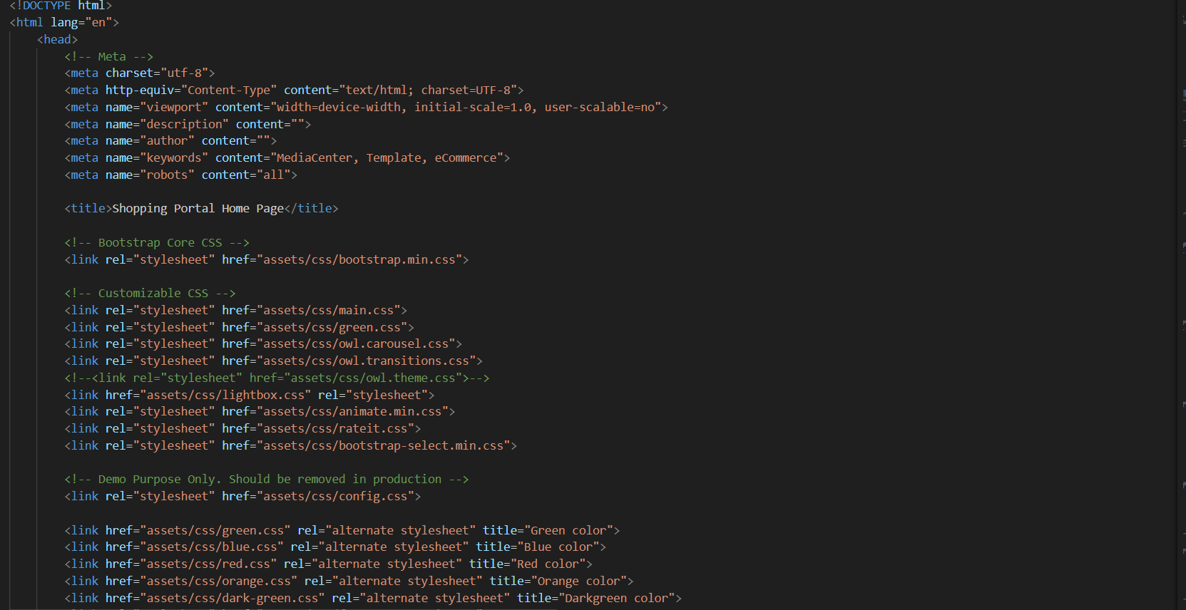

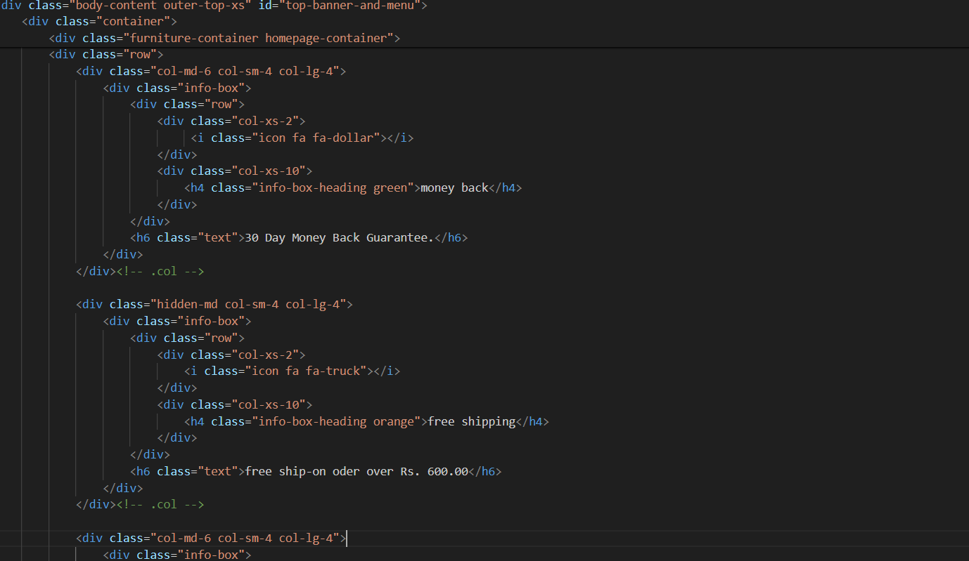

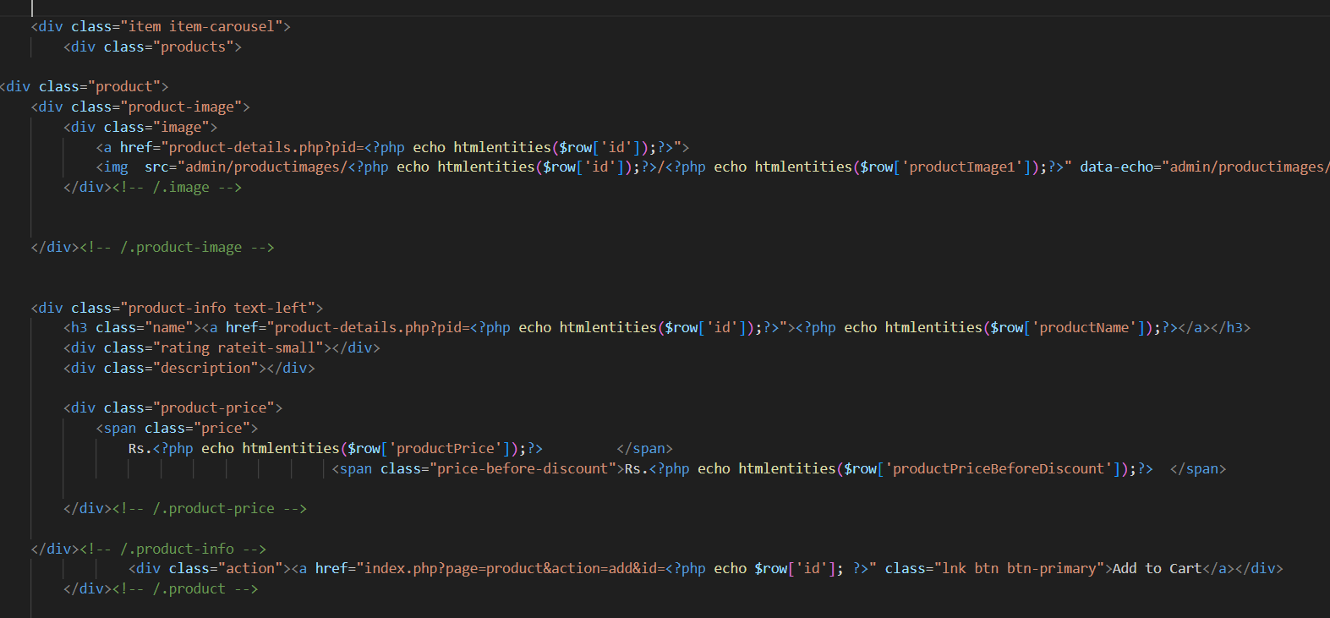

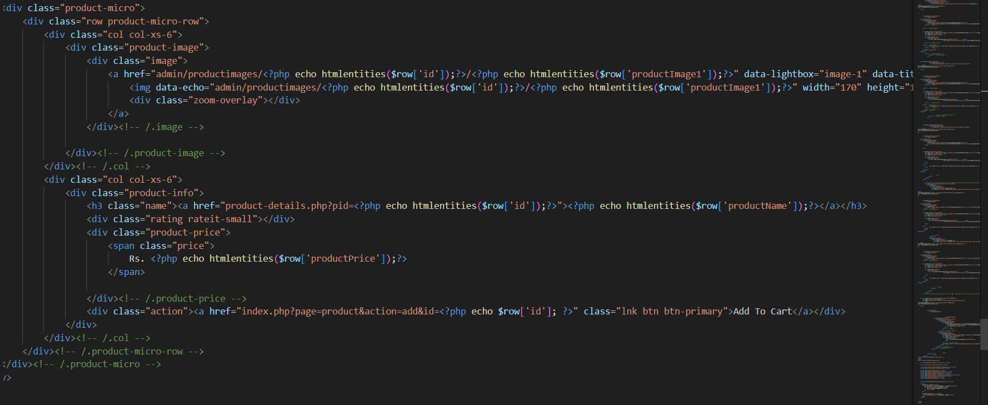

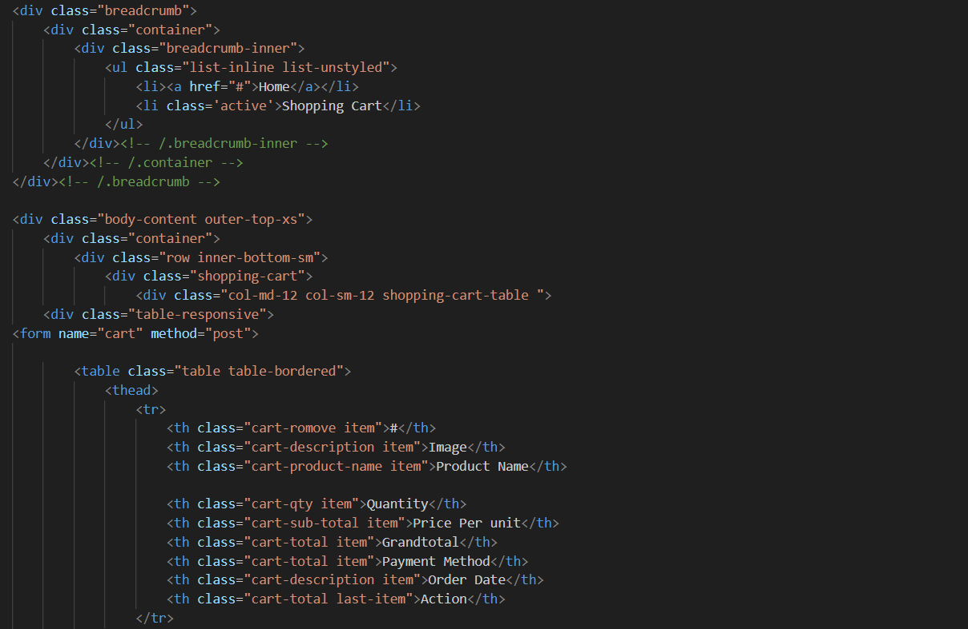



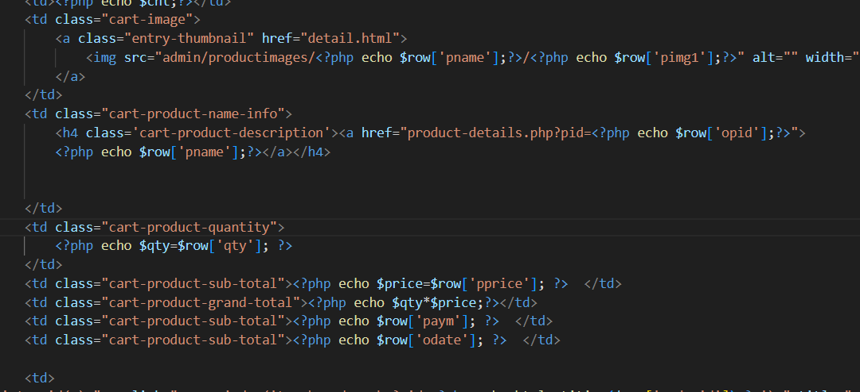

**2. CSS (Cascading Style Sheets)**

* **Styling**: CSS is used to style and format the visual appearance of HTML elements, including colors, fonts, spacing, and layout.
* **Flexibility**: CSS offers a wide range of styling options, from simple color changes to complex animations and transitions, enabling developers to create visually appealing designs.
* **Cross-Browser Compatibility**: CSS ensures consistency in the appearance of web pages across different web browsers and devices, enhancing the user experience.

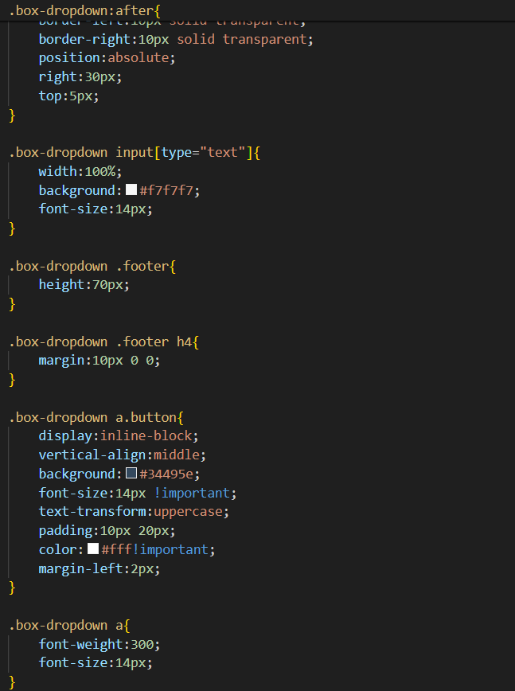

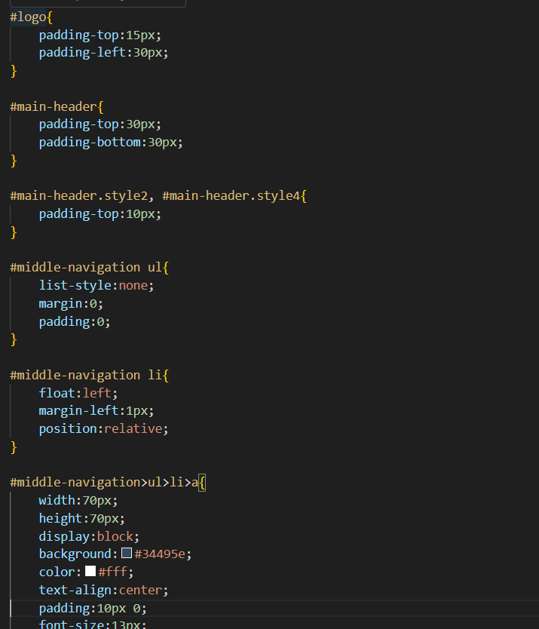

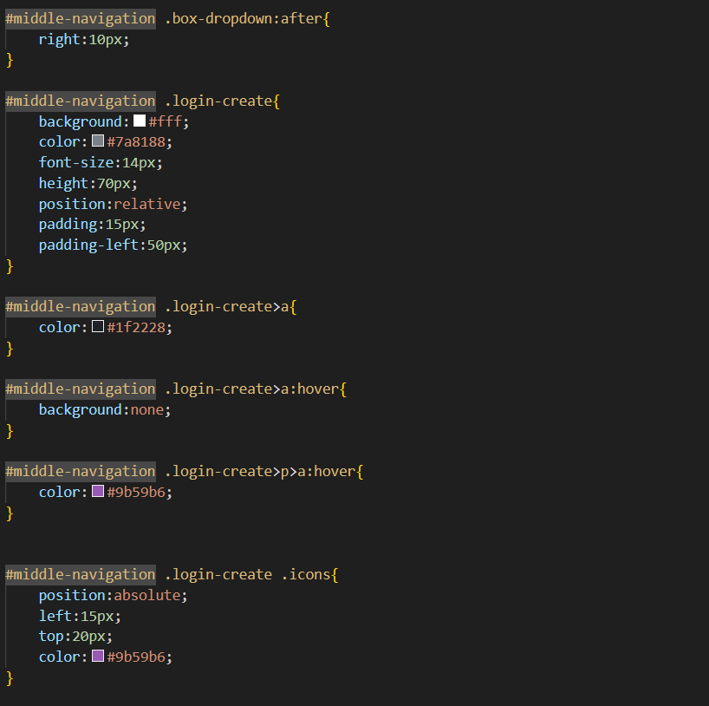

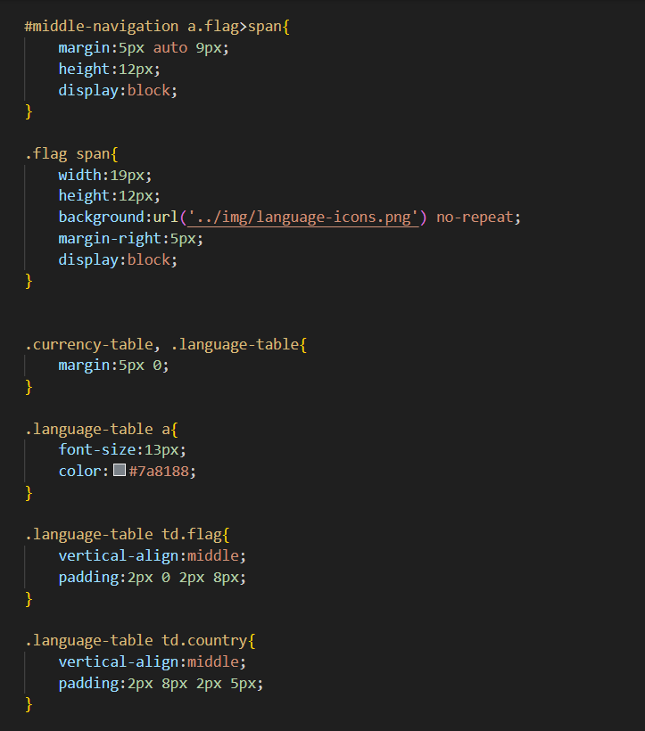



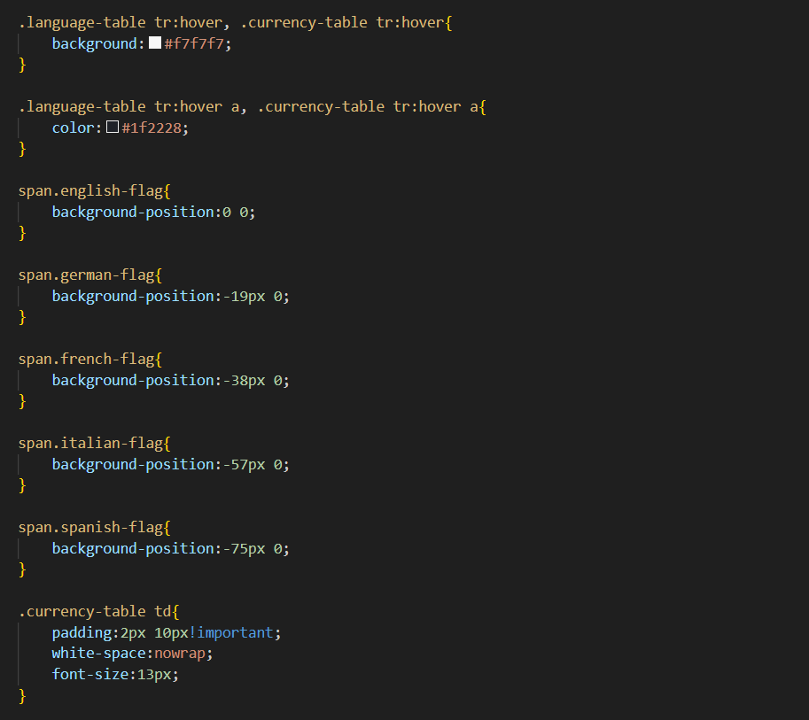

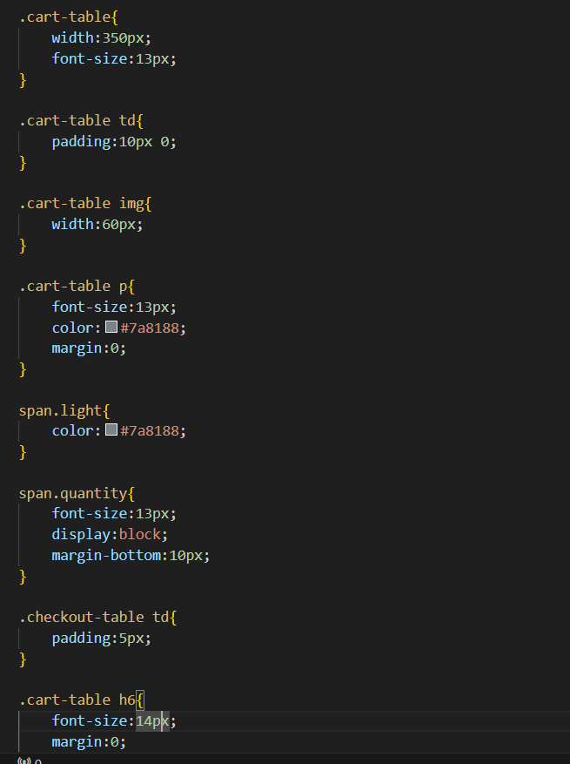

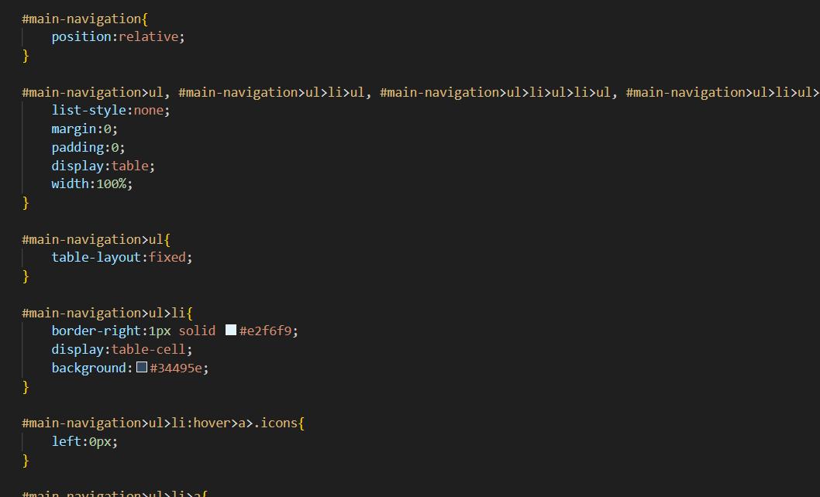

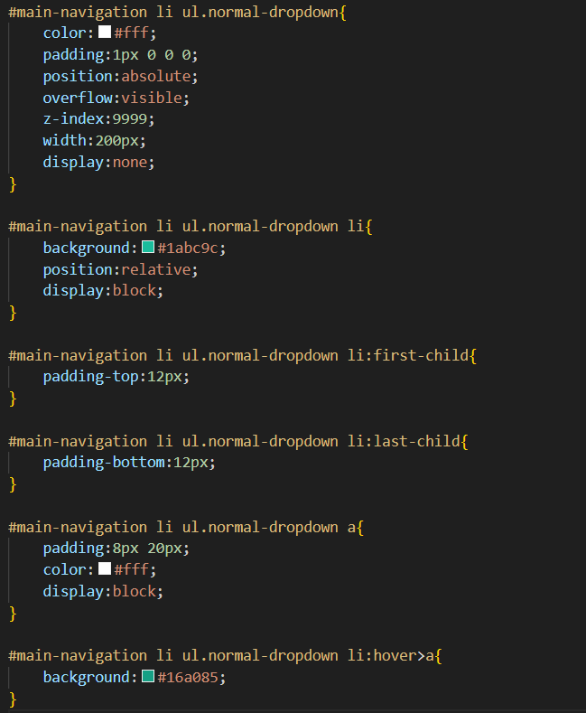



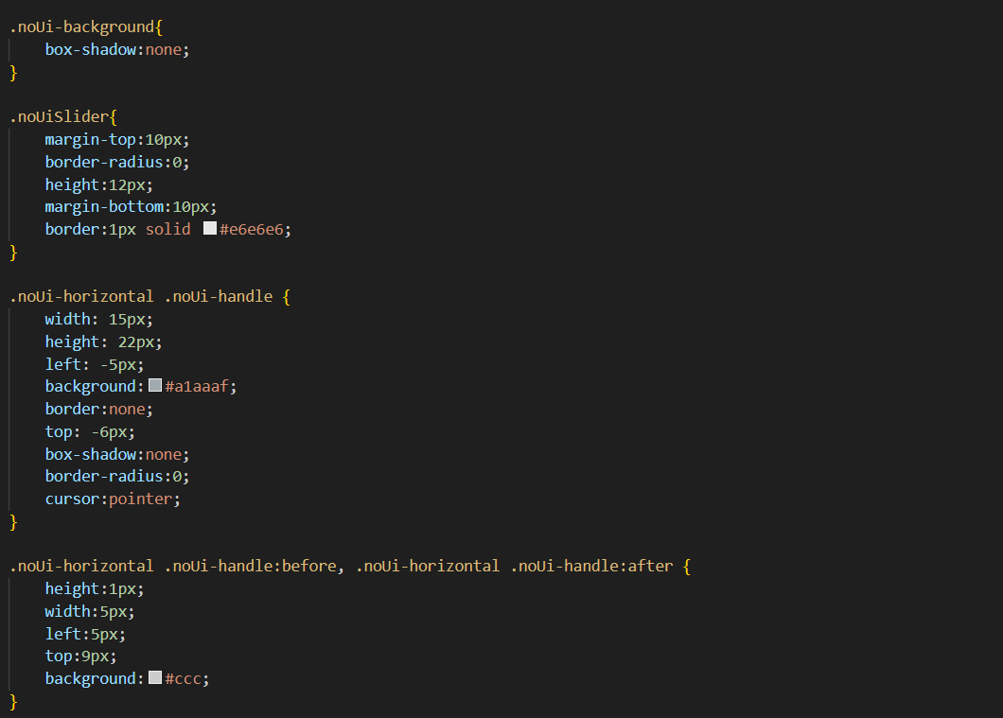

**3. JavaScript**

* **Interactivity**: JavaScript adds interactivity and dynamic behavior to web pages, allowing developers to create interactive elements such as dropdown menus, sliders, and form validations.
* **Event Handling**: JavaScript enables developers to respond to user actions and events, such as clicks, scrolls, and keyboard inputs, enhancing the user experience and functionality of web pages.
* **DOM Manipulation**: JavaScript allows developers to manipulate the Document Object Model (DOM) of web pages dynamically, enabling them to update and modify page content in real time.



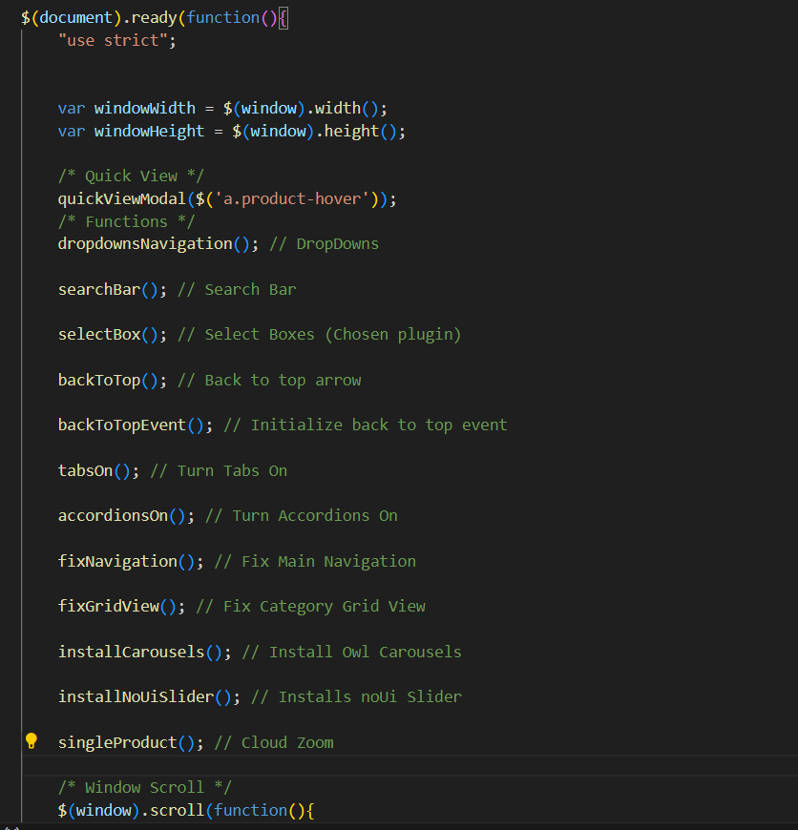

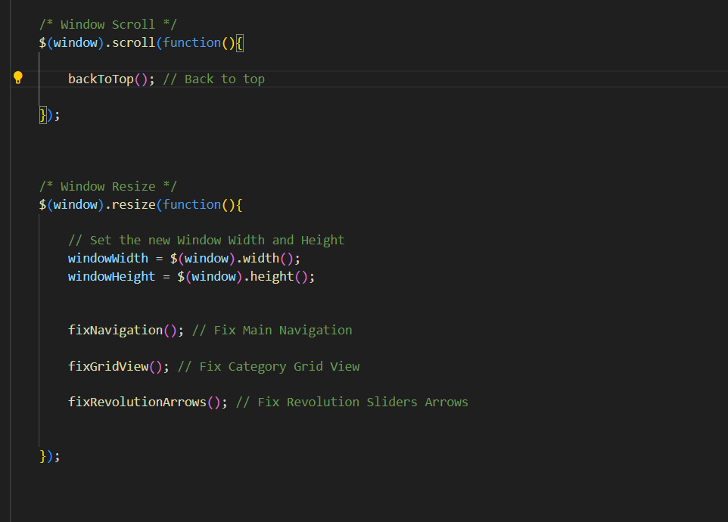

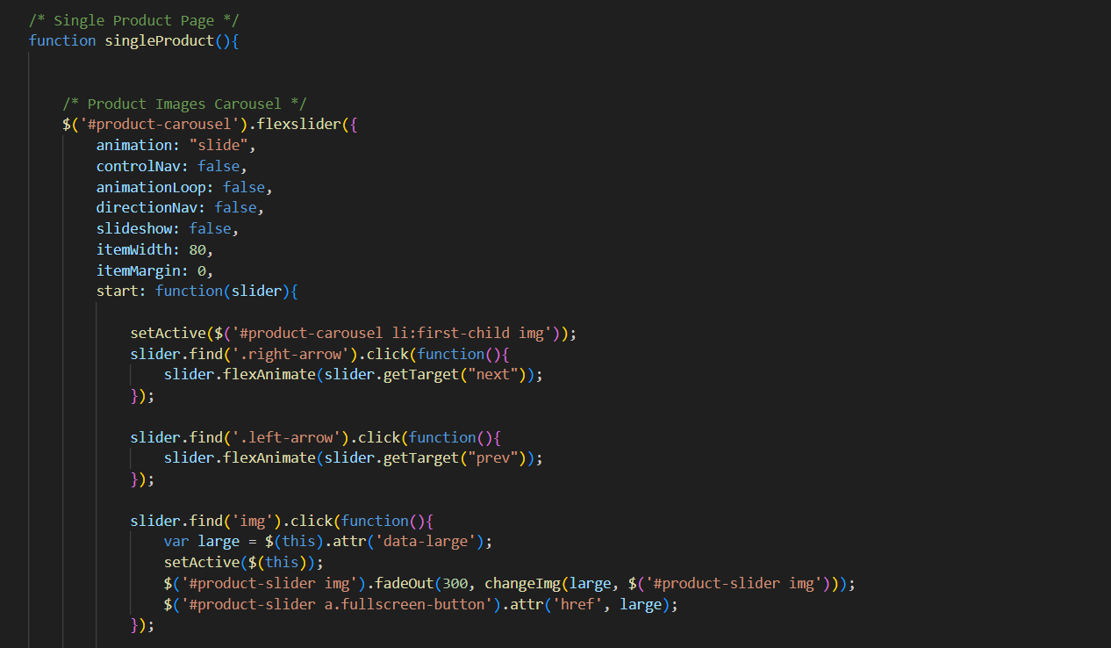

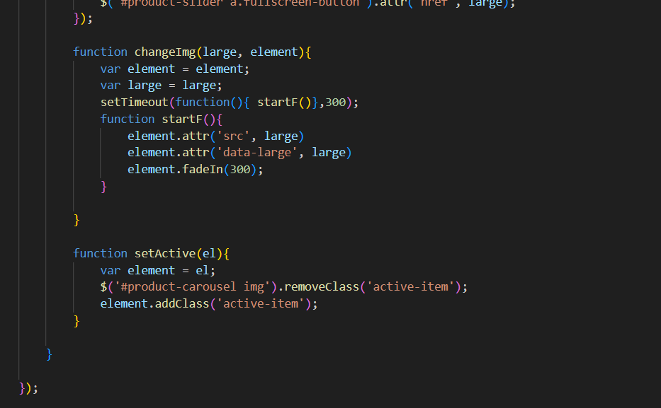

**4. jQuery**

* **Simplification**: jQuery is a fast, lightweight JavaScript library that simplifies the process of DOM manipulation, event handling, and AJAX interactions.
* **Cross-Browser Compatibility**: jQuery abstracts away the differences between various web browsers, providing a consistent and reliable development experience across different platforms.
* **Extensibility**: jQuery offers a wide range of plugins and extensions that extend its functionality, allowing developers to add advanced features and functionality to their web applications with ease.

**Importance of Front End Development:**

* **User Experience**: The front end plays a crucial role in shaping the user experience of a website or web application, directly influencing how users interact with and perceive the product.
* **Accessibility**: Front-end developers ensure that web pages are accessible to users with disabilities by following best practices in HTML semantics, CSS styling, and JavaScript interactivity.
* **Cross-Platform Compatibility**: Front-end development ensures that web pages are compatible with various devices and platforms, including desktops, laptops, tablets, and smartphones.
* **Performance Optimization**: Front-end optimization techniques such as minification, compression, and lazy loading improve page load times and overall performance, enhancing the user experience and search engine rankings.

In summary, front-end development is essential for creating visually appealing, interactive, and user-friendly web pages and web applications that meet the needs and expectations of users in today's digital landscape.



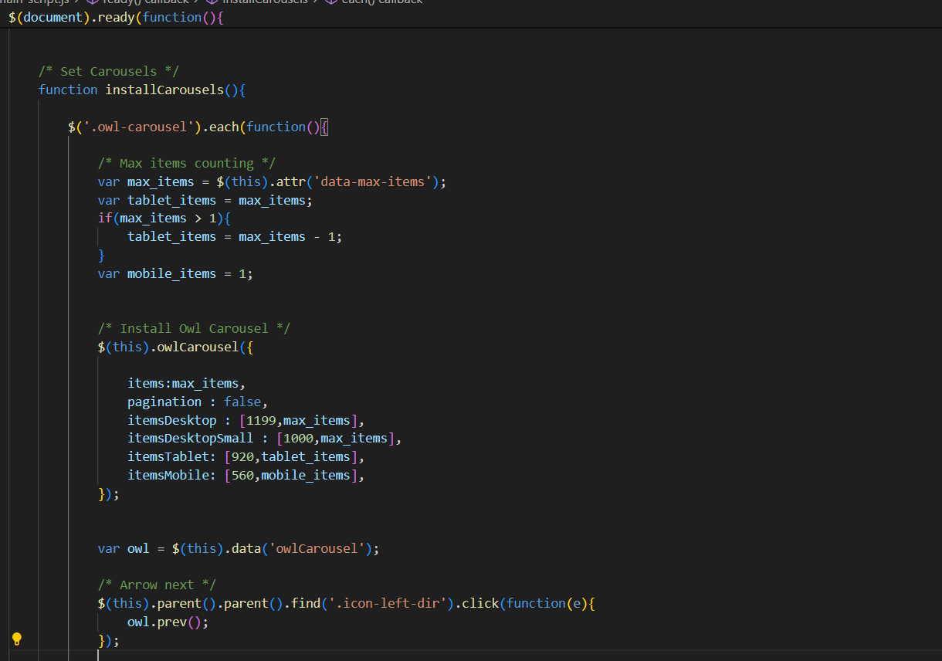

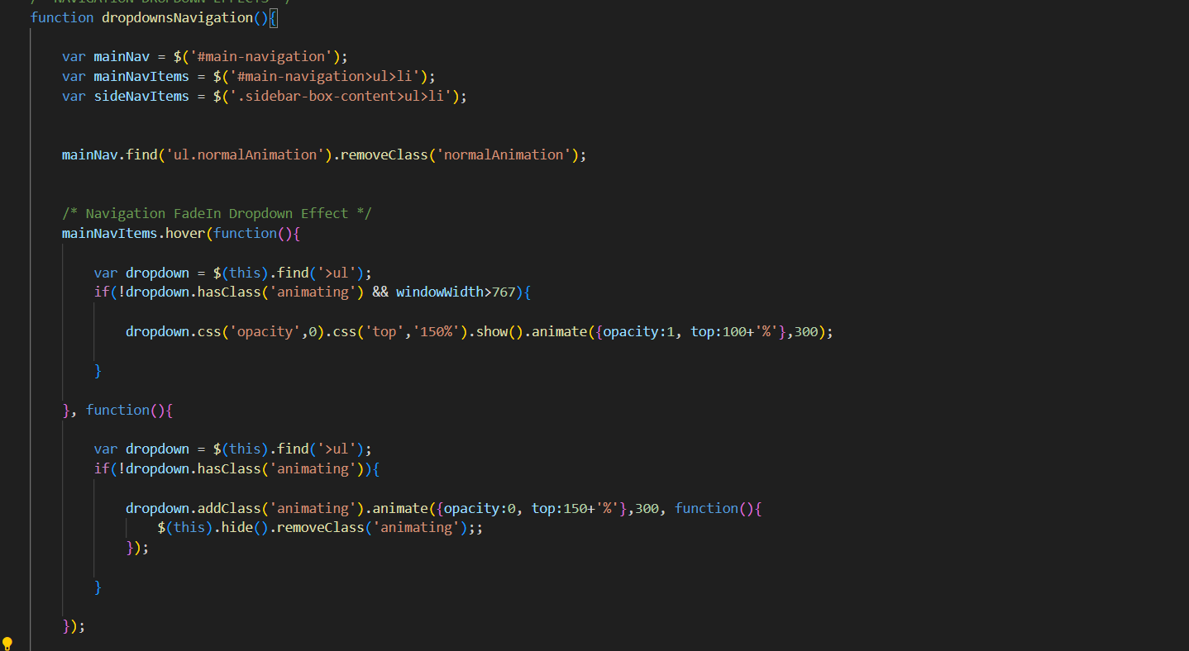

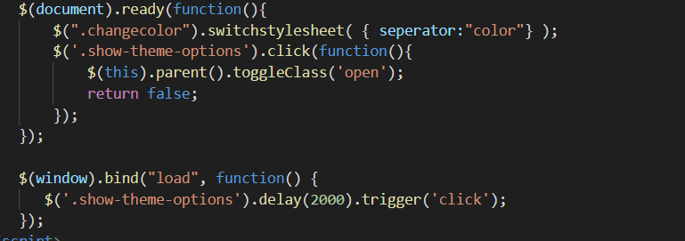

## 2.3 What is the Backend?

The backend of a website or web application refers to the server-side logic and infrastructure responsible for processing requests from the frontend, handling data storage and retrieval, and generating dynamic content to be displayed to users. While the frontend focuses on the user interface and presentation layer, the backend handles the behind-the-scenes operations that enable the frontend to function effectively.

### Reasons for Using the Backend:

### 2.3.1 Reasons for Using the Backend:

1. **Data Management**: The backend manages data storage and retrieval, including interactions with databases, file systems, and external APIs. This allows for the storage and manipulation of user data, application state, and other information necessary for the functioning of the web application.
2. **Business Logic**: Backend code contains the business logic of the application, including algorithms, calculations, and rules that govern how data is processed and operations are performed. This ensures consistency, security, and integrity in data processing and application behavior.
3. **Authentication and Authorization**: The backend handles user authentication and authorization processes, verifying user credentials, managing sessions, and enforcing access control policies. This ensures that only authorized users can access protected resources and perform specific actions within the application.
4. **Security**: Backend systems implement security measures to protect against common threats such as SQL injection, cross-site scripting (XSS), and unauthorized access. This includes input validation, data sanitization, encryption, and other security best practices to safeguard sensitive data and prevent security breaches.
5. **Performance Optimization**: Backend optimization techniques, such as caching, database indexing, and asynchronous processing, improve the performance and scalability of web applications. This ensures that the application can handle increasing traffic and workload efficiently without compromising performance.

### 2.3.2 Backend Types and Their Use Cases:

1. **Traditional Server-Side Languages**: Backend development traditionally involves languages such as PHP, Python, Ruby, and Java, which are used to create server-side scripts and applications. These languages are well-suited for handling HTTP requests, interacting with databases, and implementing business logic.
2. **Node.js**: Node.js is a runtime environment that allows developers to run JavaScript on the server-side. It is particularly popular for building real-time, data-intensive applications, such as chat applications, streaming platforms, and APIs, due to its event-driven, non-blocking I/O model.
3. **Serverless Architectures**: Serverless architectures, such as AWS Lambda and Google Cloud Functions, abstract away the server infrastructure, allowing developers to focus on writing code without managing servers. This approach is ideal for event-driven, scalable applications with unpredictable workloads.
4. **Microservices**: In a microservices architecture, backend functionality is decomposed into small, independent services that communicate with each other via APIs. This allows for greater flexibility, scalability, and maintainability, as each service can be developed, deployed, and scaled independently.
5. **APIs (Application Programming Interfaces)**: Backend systems often expose APIs that allow frontend and other external clients to interact with the application. APIs define the contract between the frontend and backend, specifying the endpoints, request/response formats, and authentication mechanisms.

**2.2.3 The Techniques Used in the Backend**

In the backend of our web application, we utilize PHP and MySQL, along with the mysqli_connect function, to establish a connection with the database and perform data operations efficiently. Here's an overview of the techniques we employ:

**PHP**

* **Server-Side Scripting**: PHP is a server-side scripting language that enables us to generate dynamic content, interact with databases, handle form submissions, and perform other server-side operations.
* **Easy Integration**: PHP seamlessly integrates with MySQL, making it an ideal choice for backend development in web applications where database interactions are prevalent.
* **Robust Community Support**: PHP boasts a vast and active community of developers, offering extensive documentation, tutorials, and resources for learning and troubleshooting.

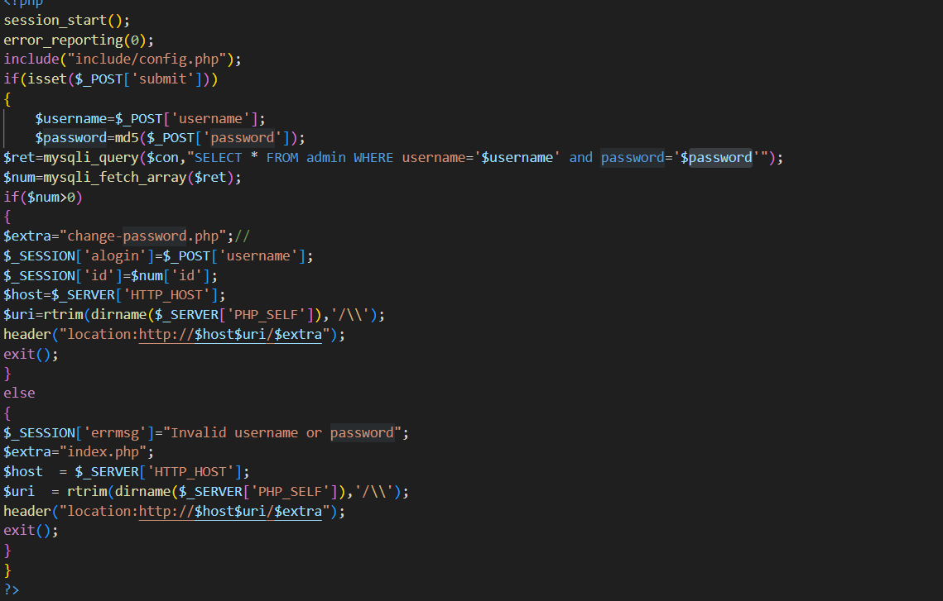

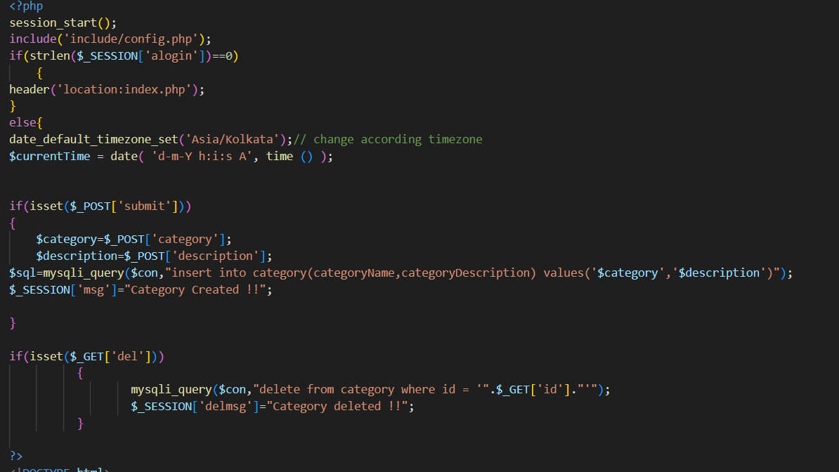

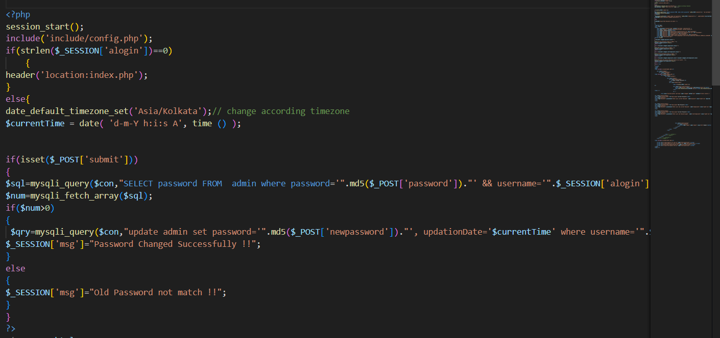

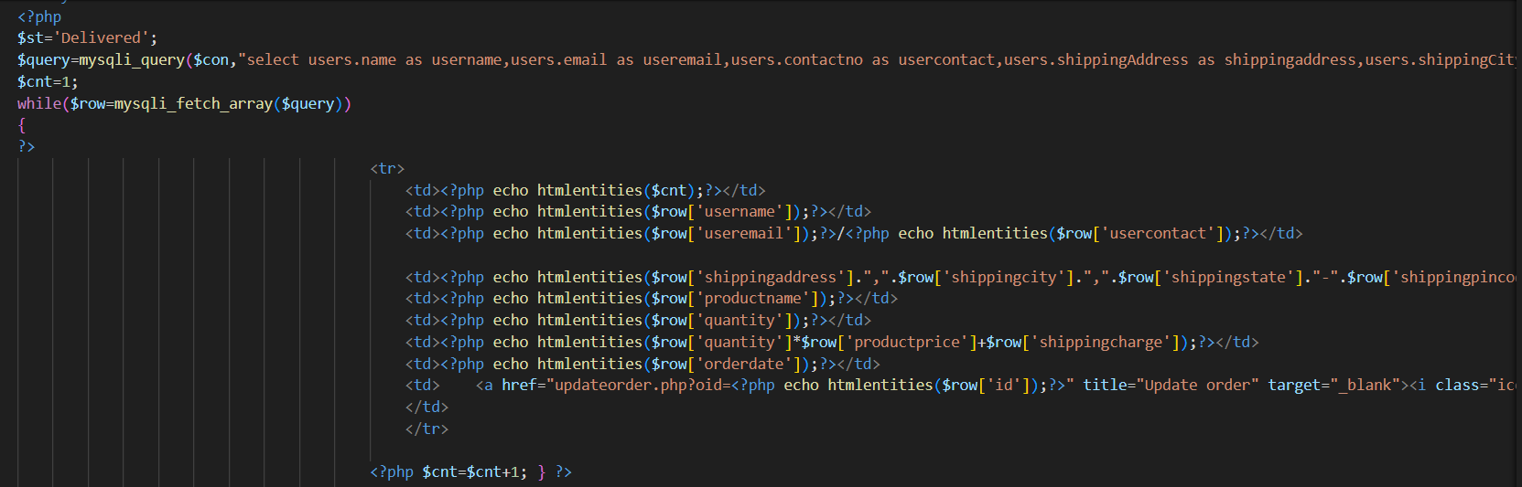

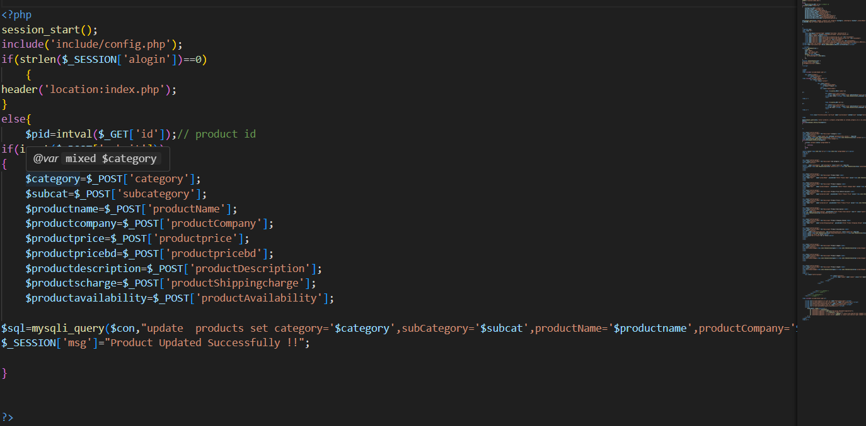

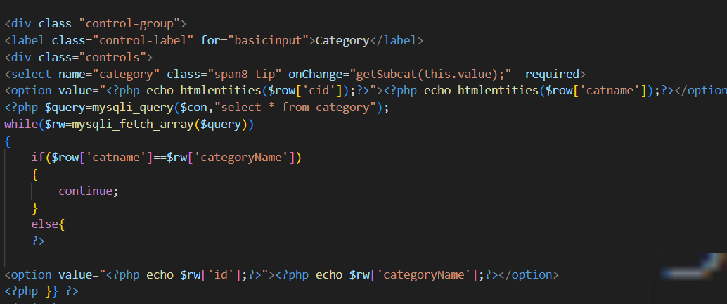

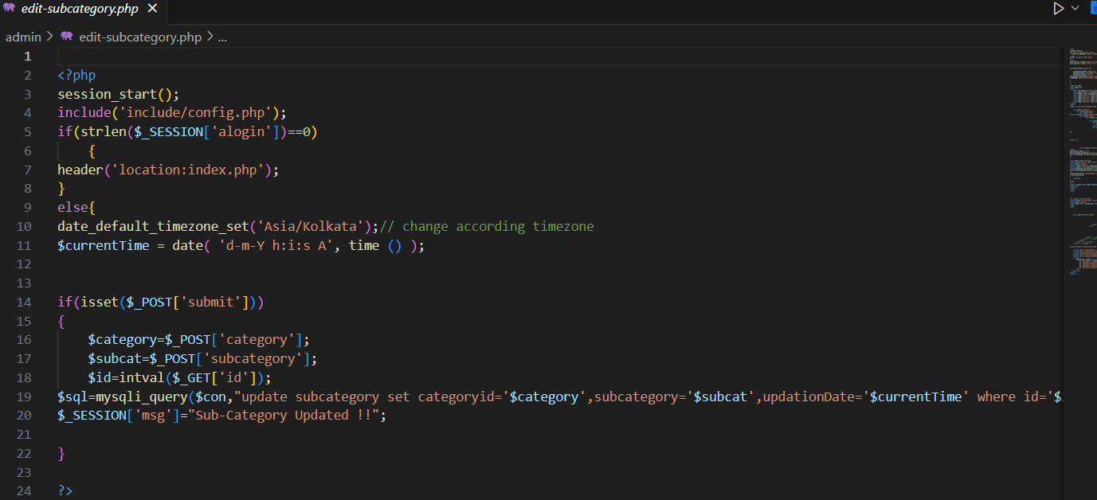

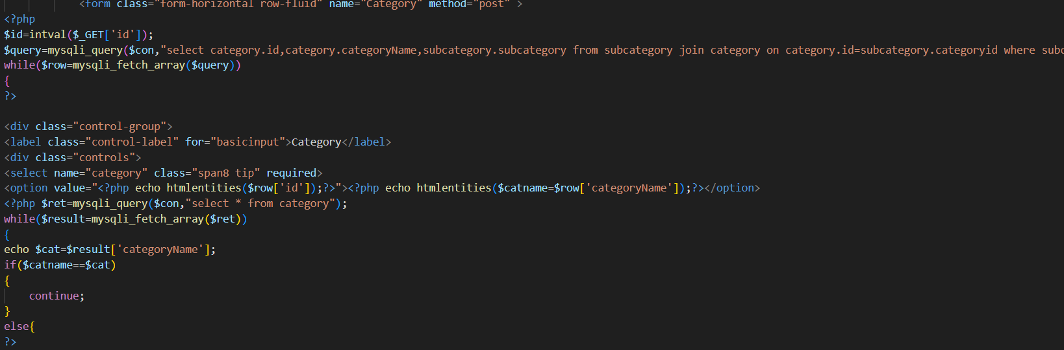

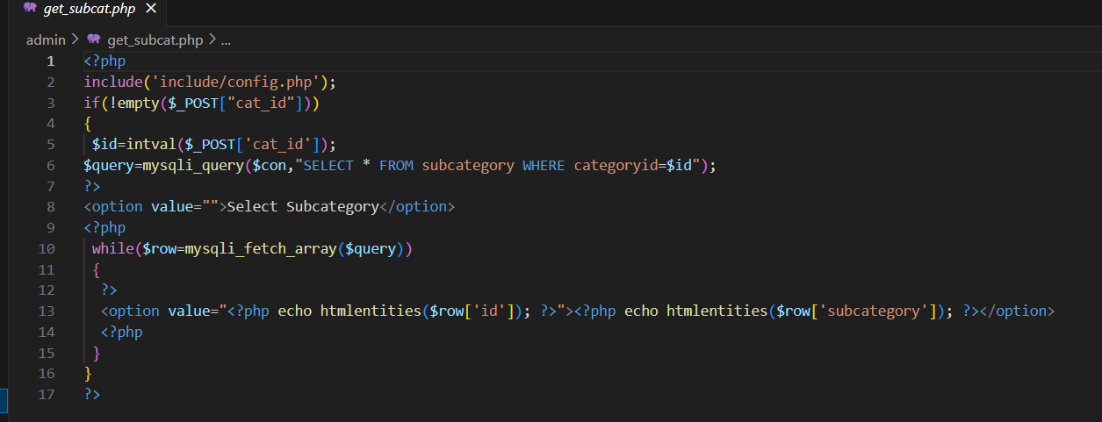

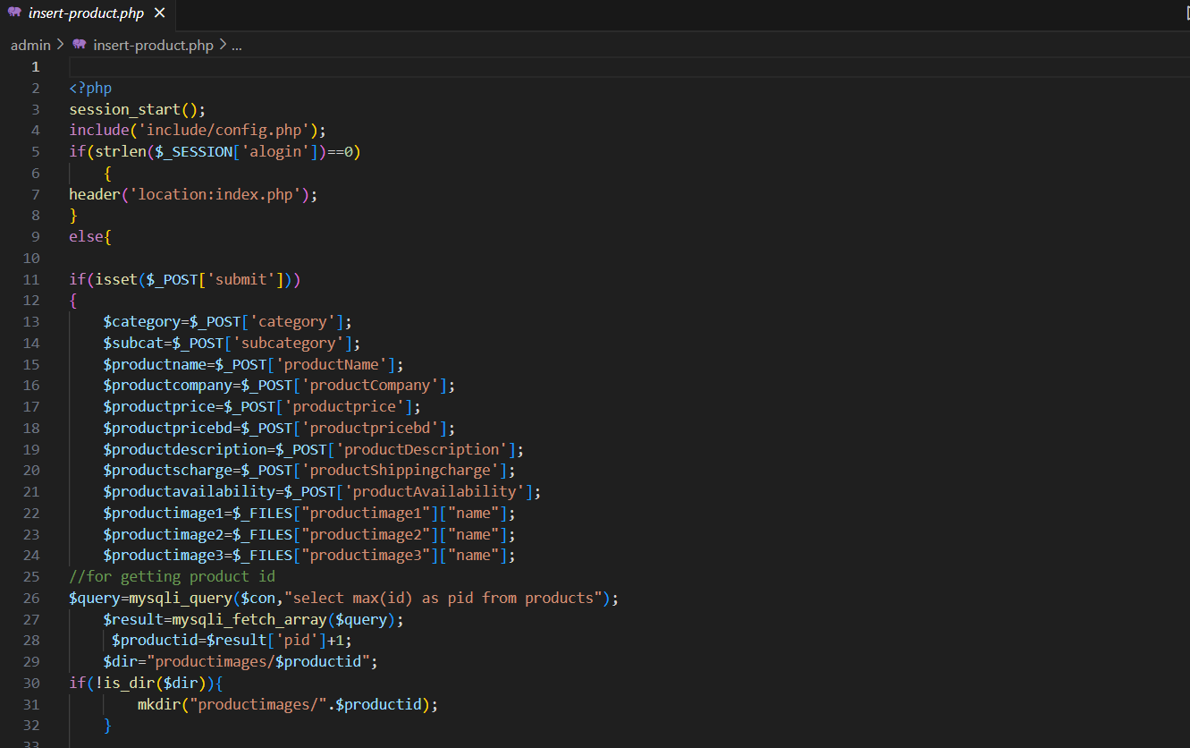



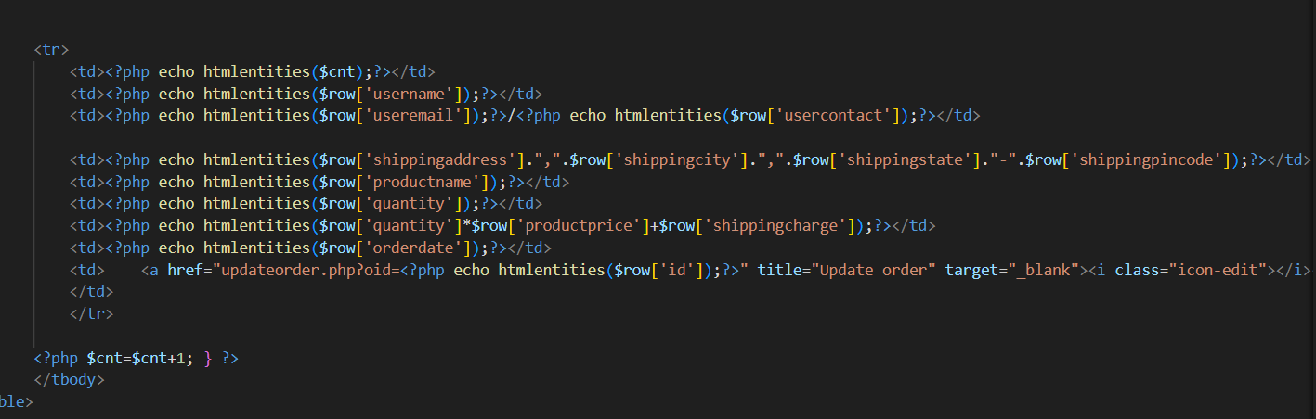

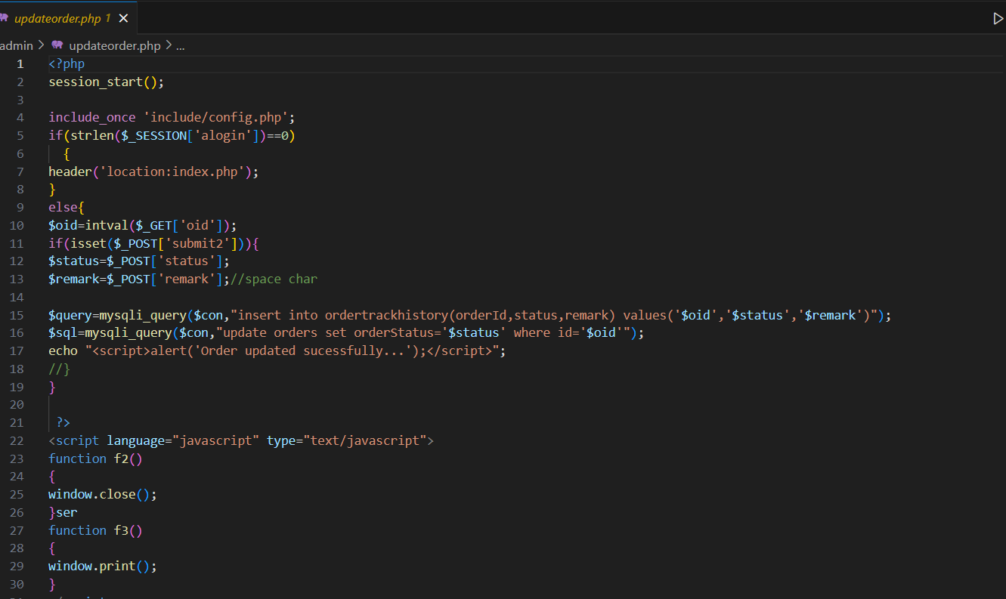

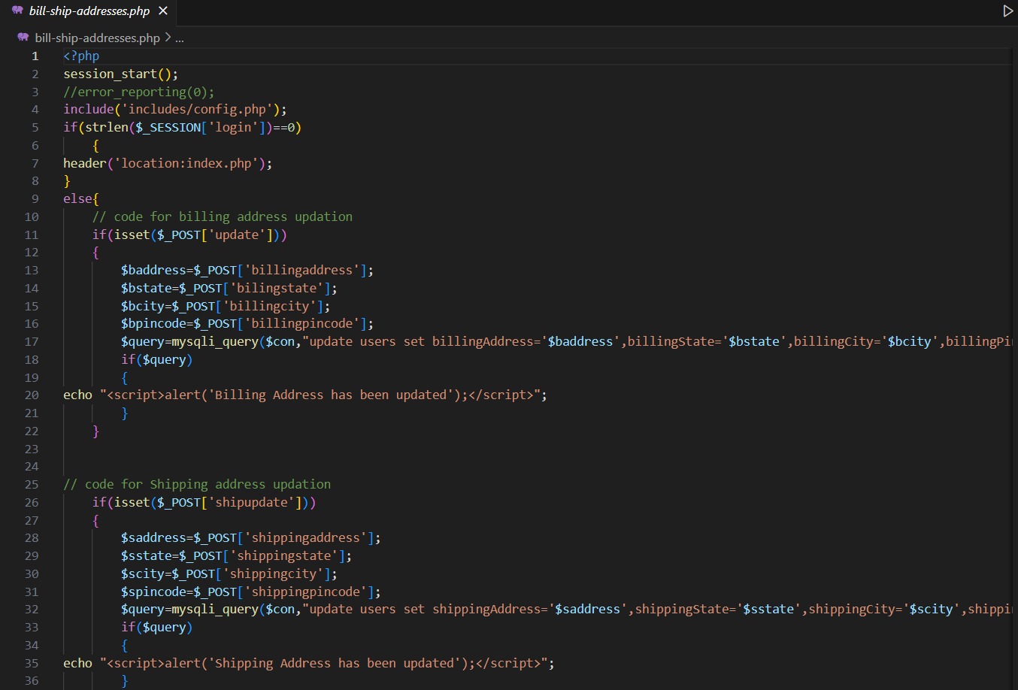

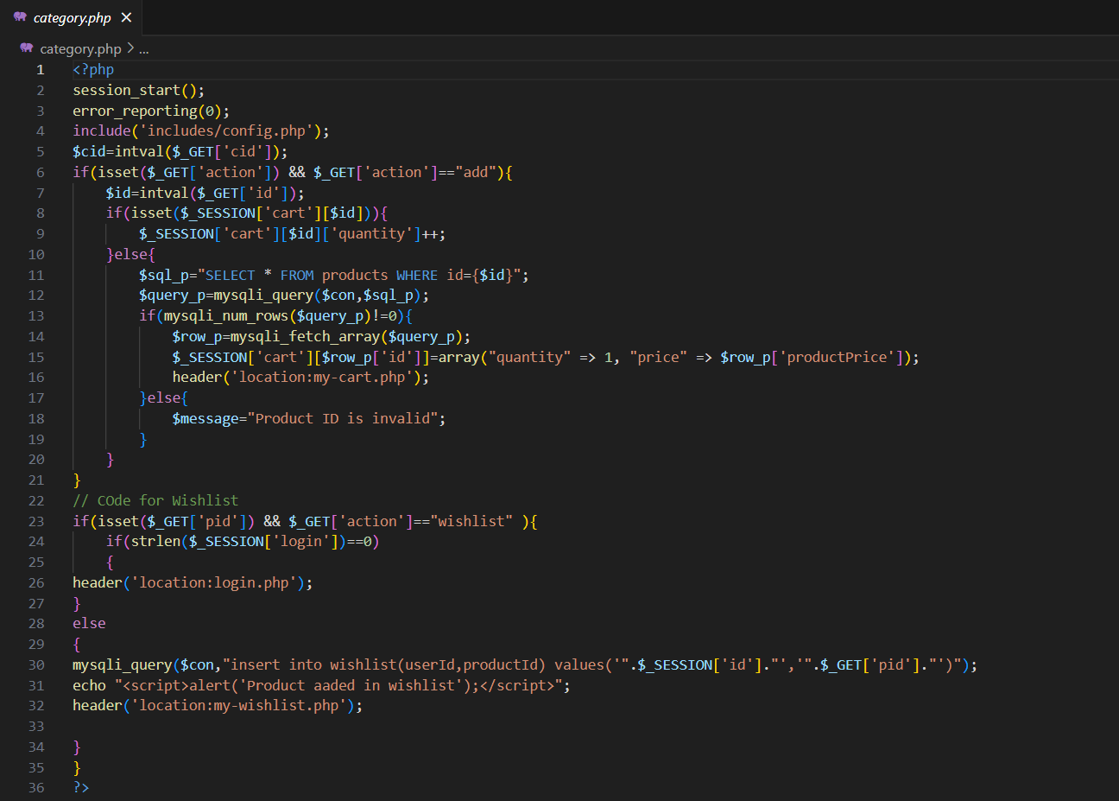

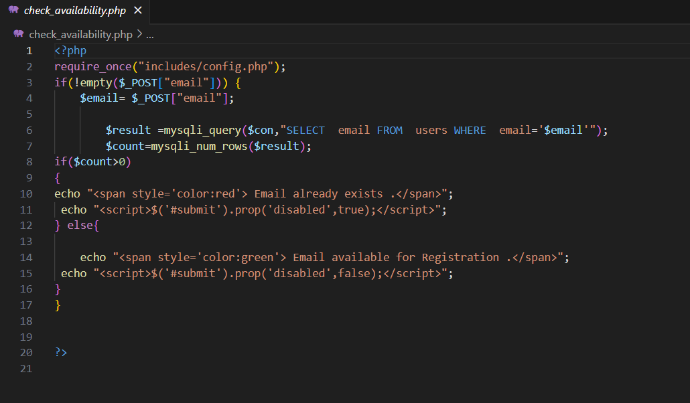

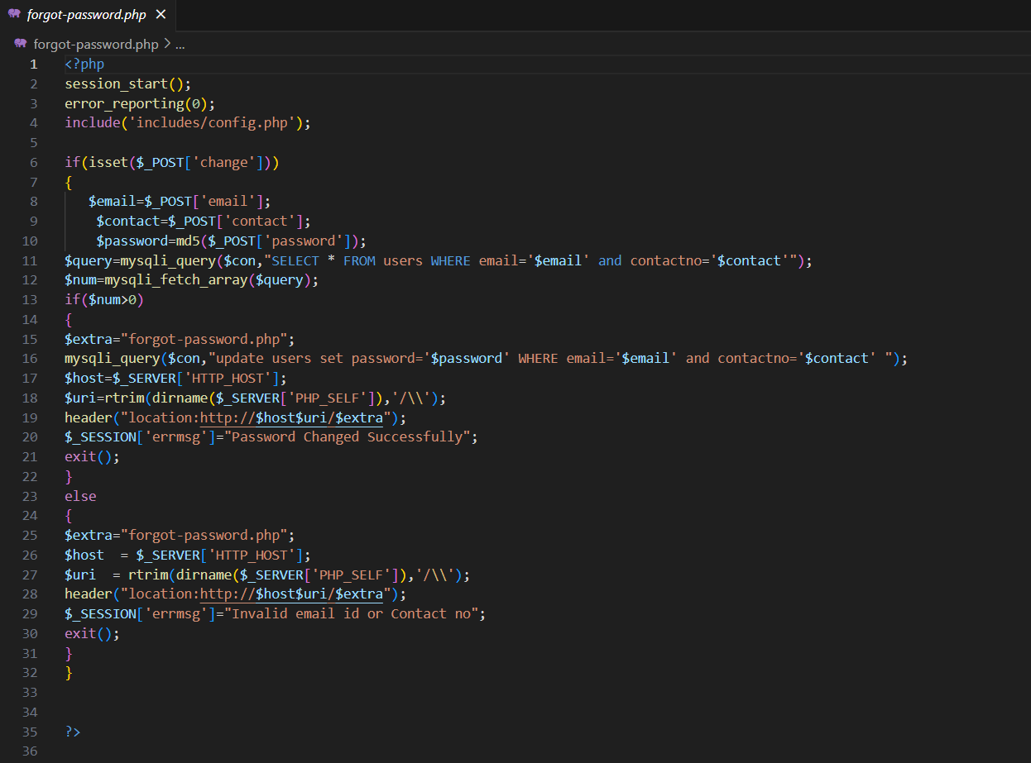

Login page

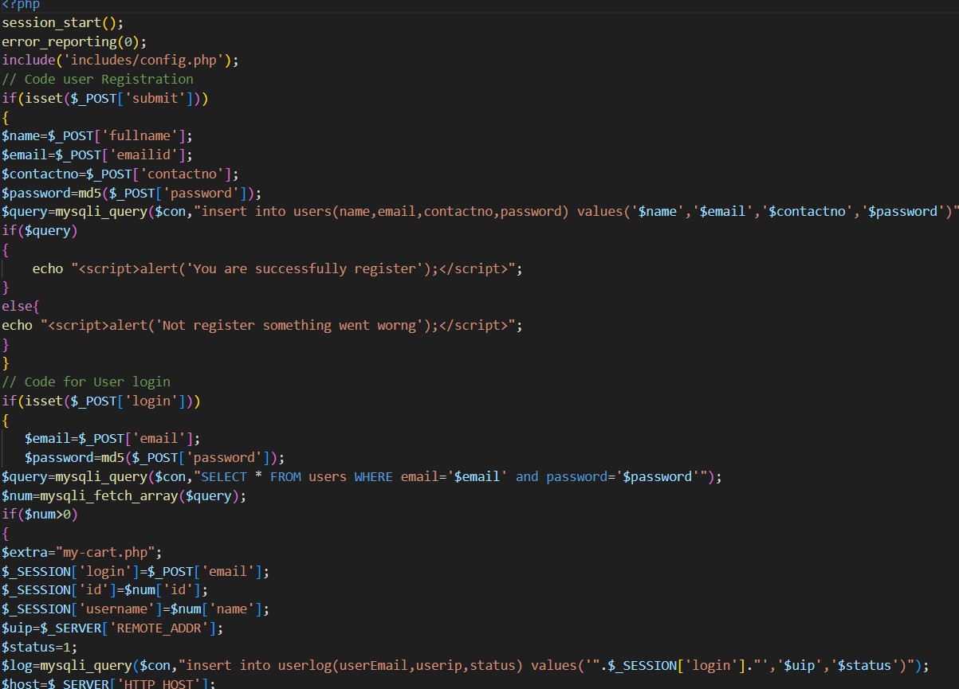

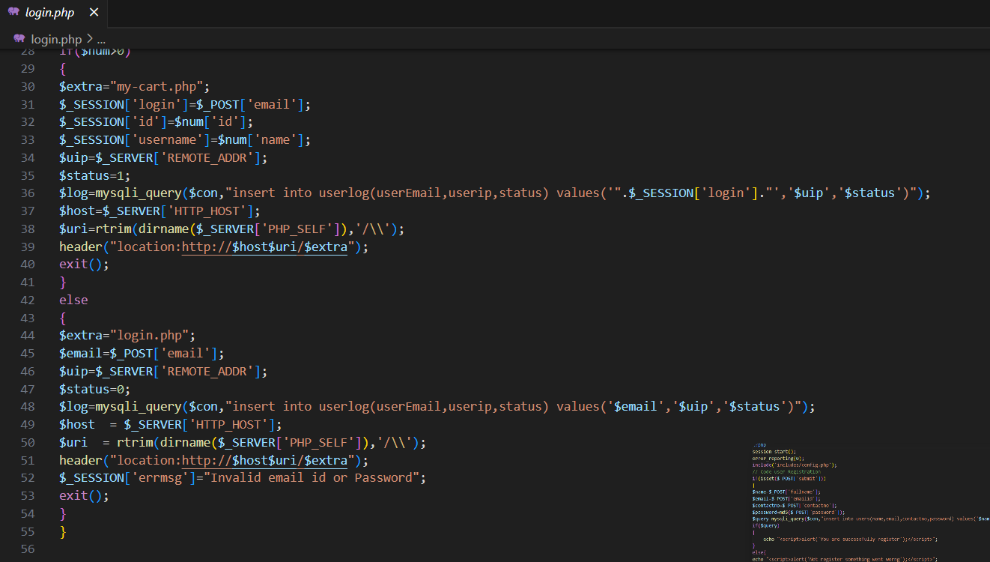

**Movie Recommendation System Documentation**

**Overview**

The Movie Recommendation System implemented on our website is designed to enhance user engagement by providing personalized movie recommendations based on user ratings. By leveraging user opinions and preferences, the system suggests movies to users that align with their tastes, thereby improving the overall user experience.

**Functionality**

**User Ratings:** Users rate movies they have watched, providing a numerical rating or feedback on their viewing experience**.**

**Storage:** User ratings are stored securely in our MySQL database, associating each rating with the respective user and movie**.**

**Recommendation Generation**: Based on the aggregated user ratings, the system generates movie recommendations for each user**.**

**Display:** These recommendations are then displayed to users on our website, prominently featured to encourage exploration and engagement.

**Architecture**

**Frontend:** The frontend of our website is built using HTML, CSS, and JavaScript, providing a user-friendly interface for rating movies and accessing recommendations.

**Backend:** Powered by PHP, the backend server handles user requests, processes ratings, generates recommendations, and communicates with the database.

**Database:** MySQL database stores user ratings, movie data, and recommendation-related information, ensuring data integrity and reliability.

**Usage**

**Rating Movies:** Users rate movies by visiting the dedicated movie rating interface on our website, where they can provide ratings based on their viewing experience.

**Viewing Recommendations**: Users can access personalized movie recommendations by navigating to the recommendation page, where curated suggestions based on their ratings are displayed.

**Future Enhancements**

**Improved Recommendation Algorithms:** Continuously refine and optimize recommendation algorithms to enhance accuracy and relevance**.**

**Enhanced User Experience:** Implement features such as personalized recommendation feeds, recommendation updates based on user activity, and integration with external APIs for richer movie data**.**

**Conclusion**

The Movie Recommendation System enriches the user experience on our website by offering personalized movie recommendations tailored to each user's preferences. By leveraging user ratings and opinions, we strive to connect users with movies they are likely to enjoy, fostering engagement and satisfaction**.**

**Movie rating**

First, users start rating movies from here

Secondly, we analyze this data and display it through the recommendation system and show the other user all the other users' ratings of movies to review these ratings and help her recommend some movies based on this recommendation made by other users.

**This is where recommendations are shown based on user ratings**

**MySQL Database**.

**mysqli_connect Function**

* **Database Connection**: The mysqli_connect function is used in PHP to establish a connection with the MySQL database server.

**3.2.1: Entity Relationship Diagram (ERD) :**An entity–relationship model (or ER model) describes interrelated things of interest in a specific domain of knowledge. A basic ER model is composed of entity types (which classify the things of interest) and specifies relationships that can exist between entities (instances of those entity types

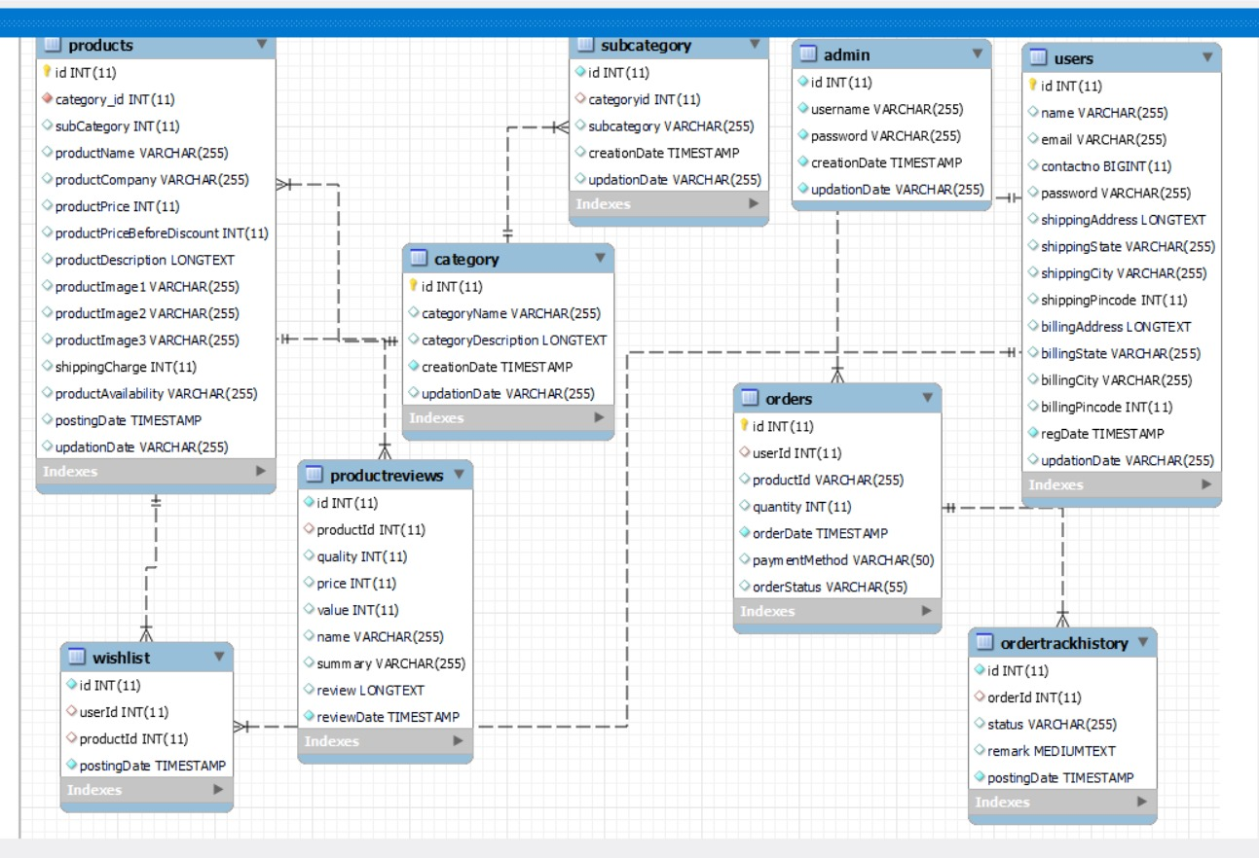

**Admin Attributes:**

1-Id

2-Usernam**e**

3-Password

4- CreationDate

5- UpdationDate

**Category Attributes :**

1-Id

2-CategoryName

3-CategoryDescription

4-CreationDate

5-UpdationDate

**Order Attributes :**

1-Id

2-UserId

3-ProductId

4-Quantity

5-OrderDate

6-PaymentMethod

7-OrderStatus

**OrderTrackhistory Attributes :**

1-Id

2-UserId

3-Status

4-Remark

5-postingDate

**Productreview Attributes:**

1-id

2-productId

3-quality

4-price

5-value

6-name

7-summary

8-review

9-reviewDate

**Products Attributes:**

1-Id

2-Category_id

3-Subcategory

4-productName

5-productCompany

6-productPrice

7-productPriceBeforeDiscount

8-productDescription

9-productImage1

10-productImage2

11-productImage3

12-shippingCharge

13-productAvailability

14-postingDate

15-UpdationDate

**SubCategory Attributes :**

1-Id

2-CategoryId

3-SubCategory

4-creationDate

5-UpdationDate

**User Attributes**:

1-Id

2-Name

3-Email

4-ContactNo

5-Password

6-ShippingAddress

7-shippingState

8-shippingCity

9-shippingPincode

10-billingAddress

11-billingState

12-billingCity

13-billingPincode

14-regDate

15-UpdationDate

**WishList Attributes**:

1-Id

2-UserId

3-ProductId

4-postingDate

**Data Flow Diagram:**

**Use Case Diagram :**

**Activity Diagram:**

1-Activity Diagram for User side

2-Activity diagram for admin side

**4-class diagram:**

**2.3.3 Firebase Integration**

**2.3.3.1 Defining Firebase and Knowing Its History**

Firebase is a comprehensive platform for building web and mobile applications developed by Firebase, Inc., which was later acquired by Google in 2014. It provides a wide range of services and tools for app development, including real-time database, authentication, hosting, cloud functions, and analytics.

**2.3.3.2 Firebase History**

Firebase was initially launched in 2011 as a real-time backend service for web and mobile developers. Over the years, it evolved into a full-fledged app development platform with a suite of integrated services, making it easier for developers to build, deploy, and manage applications.

**2.3.3.3 Popular Apps Using Firebase**

Firebase is widely used by developers and companies across various industries to power their applications. Some popular apps using Firebase include:

* **Instacart**: A grocery delivery and pickup service that relies on Firebase for real-time updates and notifications.
* **The New York Times**: The news organization uses Firebase to deliver personalized content and engage users with targeted notifications.
* **Duolingo**: A language-learning platform that utilizes Firebase for user authentication, data synchronization, and analytics.

**2.3.3.4 Firebase Use Cases**

Firebase offers a range of use cases for developers, including:

* **Real-Time Database**: Firebase Realtime Database enables developers to synchronize application data in real-time across multiple clients.
* **Authentication**: Firebase Authentication provides easy-to-use authentication solutions, including email/password, social authentication, and phone number authentication.
* **Cloud Functions**: Firebase Cloud Functions allow developers to run server-side code in response to events triggered by Firebase features and HTTPS requests.

**2.3.3.5 Firebase Limitations**

While Firebase offers many benefits for app development, it also has some limitations to consider:

* **Vendor Lock-In**: Using Firebase services may result in vendor lock-in, as migrating away from Firebase to another platform can be challenging.
* **Limited Query Capabilities**: Firebase Realtime Database has limited query capabilities compared to traditional relational databases like MySQL.
* **Cost**: Depending on usage, Firebase services may incur costs, especially as the scale of the application grows.

Chapter 3: Implementation

**3.1: Software Techniques**

Software techniques encompass the strategies, methodologies, and tools used in the design, development, testing, and maintenance of software applications. In the context of developing ecommerce shopping, a robust e-commerce platform, various software techniques are employed to ensure the application is efficient, scalable, secure, and user-friendly. This section outlines the key software techniques utilized in the development process.

**1. Agile Methodology**

* **Iterative Development**: Agile methodology emphasizes iterative development cycles, known as sprints, allowing for continuous feedback and improvement.
* **Collaboration**: Agile promotes close collaboration between cross-functional teams, including developers, designers, testers, and stakeholders, ensuring alignment with project goals.
* **Flexibility**: Agile techniques enable the team to adapt to changing requirements and priorities, enhancing responsiveness to market and user needs.

**2. Object-Oriented Programming (OOP)**

* **Modularity**: OOP techniques, used in languages like PHP, promote modular code design, making it easier to manage, maintain, and extend the application.
* **Encapsulation**: Encapsulation helps in hiding the internal state of objects and exposing only necessary functionalities, improving code security and robustness.
* **Inheritance and Polymorphism**: These OOP principles allow for code reuse and flexibility, enabling the creation of complex systems with less redundancy.

**3. MVC Architecture**

* **Separation of Concerns**: The Model-View-Controller (MVC) architecture separates the application logic into three interconnected components: the model (data), the view (user interface), and the controller (business logic). This separation enhances code organization and maintainability.
* **Scalability**: MVC architecture facilitates the development of scalable applications by allowing independent development and testing of components.
* **Reusability**: MVC promotes the reuse of code across different parts of the application, reducing duplication and improving efficiency.

**4. Responsive Design**

* **Flexibility**: Responsive design techniques, implemented using CSS and frameworks like Bootstrap, ensure that the application provides an optimal user experience across various devices and screen sizes.
* **Media Queries**: CSS media queries allow for the application of different styles based on device characteristics, such as width, height, and orientation, enabling adaptive layouts.
* **Fluid Grids and Flexible Images**: These techniques ensure that the layout and media elements scale proportionally, maintaining usability and aesthetics on any device.

**5. AJAX and Asynchronous Programming**

* **Improved User Experience**: AJAX techniques enable asynchronous data loading, allowing for smoother and more responsive user interactions without full page reloads.
* **Real-Time Updates**: AJAX facilitates real-time data updates and interactions, essential for features like dynamic content loading, live search, and interactive forms.
* **Reduced Server Load**: By requesting only necessary data from the server, AJAX reduces the load on the server and bandwidth usage, improving overall performance.

**6. Version Control with Git**

* **Collaboration**: Git enables multiple developers to work on the same project simultaneously, tracking changes and merging contributions efficiently.
* **History and Rollback**: Git maintains a detailed history of changes, allowing developers to revert to previous states in case of errors or issues.
* **Branching and Merging**: Git's branching and merging capabilities facilitate parallel development, experimentation, and integration of new features without disrupting the main codebase.

**7. Testing and Quality Assurance**

* **Automated Testing**: Automated testing frameworks (e.g., PHPUnit for PHP) are used to write and run tests automatically, ensuring code reliability and correctness.
* **Continuous Integration (CI)**: CI tools integrate and test code changes continuously, catching issues early and facilitating smoother deployments.
* **Manual Testing**: In addition to automated tests, manual testing ensures that the application meets user expectations and functions correctly under various scenarios.

**8. Security Practices**

* **Input Validation and Sanitization**: Techniques to validate and sanitize user inputs prevent common security vulnerabilities like SQL injection and cross-site scripting (XSS).
* **Authentication and Authorization**: Secure authentication mechanisms (e.g., hashed passwords) and robust authorization checks protect sensitive data and resources.
* **Encryption**: Data encryption techniques (e.g., SSL/TLS) protect data during transmission, ensuring privacy and integrity.

By employing these software techniques, ecommerce shopping ensures the development of a high-quality, reliable, and user-friendly e-commerce platform that meets the needs of its users and withstands the demands of modern web applications.

**3.2: Analyzing the System**

System analysis is a critical phase in the software development lifecycle, where the project's requirements, goals, and constraints are thoroughly examined to ensure that the final product meets the stakeholders' needs. In the context of developing ecommerce shopping , a comprehensive e-commerce platform, system analysis involves understanding the functional and non-functional requirements, assessing potential risks, and creating a robust blueprint for the implementation process. This section outlines the key aspects of system analysis for our project.

**1. Requirements Gathering**

* **Stakeholder Interviews**: Conducting interviews with key stakeholders, including business owners, end-users, and technical teams, to gather detailed requirements and expectations for the e-commerce platform.
* **Surveys and Questionnaires**: Distributing surveys and questionnaires to a broader audience to collect additional insights and requirements from potential users and customers.
* **Use Case Scenarios**: Developing use case scenarios to understand how different users will interact with the system and what functionalities are necessary to support their needs.

**2. Functional Requirements**

* **User Management**: Analyzing the requirements for user registration, login, profile management, and account recovery functionalities.
* **Product Management**: Defining the features needed for adding, updating, and removing products, including categorization, pricing, inventory management, and product descriptions.
* **Shopping Cart and Checkout**: Identifying the necessary steps and features for the shopping cart, order processing, payment integration, and order confirmation.
* **Search and Navigation**: Determining the requirements for search functionality, filters, and navigation to help users find products easily.
* **Admin Dashboard**: Outlining the functionalities required for an admin dashboard to manage users, products, orders, and generate reports.

**3. Non-Functional Requirements**

* **Performance**: Setting performance goals for response time, load handling, and scalability to ensure the platform can handle high traffic and large datasets efficiently.
* **Security**: Identifying security requirements, such as data encryption, secure authentication, authorization mechanisms, and protection against common vulnerabilities (e.g., SQL injection, XSS).
* **Usability**: Ensuring the platform is user-friendly and accessible, with an intuitive interface, responsive design, and clear navigation paths.
* **Reliability**: Defining reliability requirements to ensure the system operates consistently, with minimal downtime and robust error handling.
* **Compliance**: Ensuring the platform meets relevant legal and regulatory requirements, such as GDPR for data protection and PCI-DSS for payment processing.

**4. System Architecture**

* **Technical Stack**: Selecting the appropriate technologies for the backend (PHP, MySQL), frontend (HTML, CSS, JavaScript, jQuery), and other tools and frameworks necessary for development.
* **Database Design**: Designing the database schema to efficiently store and manage data, including tables for users, products, orders, and other entities.
* **Integration Points**: Identifying external systems and services to integrate with, such as payment gateways, shipping providers, and third-party APIs.
* **Scalability and Load Balancing**: Planning for scalability and load balancing to ensure the system can handle increased traffic and data volume without performance degradation.

**5. Risk Assessment**

* **Identifying Risks**: Identifying potential risks that could impact the project, such as technical challenges, security vulnerabilities, and changes in requirements.
* **Mitigation Strategies**: Developing mitigation strategies to address identified risks, such as implementing security best practices, conducting thorough testing, and maintaining clear communication with stakeholders.
* **Contingency Planning**: Preparing contingency plans for critical risks to ensure the project can continue smoothly in case of unforeseen issues.

**6. Prototyping and Validation**

* **Wireframes and Mockups**: Creating wireframes and mockups to visualize the user interface and validate design concepts with stakeholders before full-scale development.
* **Prototyping**: Developing prototypes to test and validate key functionalities, gather feedback, and make necessary adjustments early in the development process.
* **User Testing**: Conducting user testing sessions to gather feedback on usability, identify issues, and refine the system based on real user interactions.

**7. Documentation and Specifications**

* **Technical Documentation**: Preparing detailed technical documentation, including system architecture diagrams, database schema, API specifications, and code documentation.
* **User Manuals**: Creating user manuals and guides to help users and administrators understand how to use the platform effectively.
* **Requirements Specification**: Compiling a comprehensive requirements specification document that outlines all functional and non-functional requirements, use cases, and acceptance criteria.

By thoroughly analyzing the system , ecommerce shopping ensures a clear understanding of the project's scope, goals, and challenges, setting a solid foundation for successful development and deployment. This meticulous analysis helps in delivering a high-quality, user-centric e-commerce platform that meets the needs of its users and stakeholders.

Chapter 4: Summary, Conclusions and Future Work .

## 4.1 Summary

In this documentation, we have provided a comprehensive overview of the development process, techniques, and methodologies employed in creating [Your Website Name], a sophisticated e-commerce platform designed to facilitate seamless online product sales. This summary highlights the key points covered in each chapter, providing a cohesive recap of the essential aspects of the project.

### Chapter 1: Introduction

The introduction set the stage for the documentation by outlining the purpose and scope of the project. We discussed the problem definition, emphasizing the need for a robust and user-friendly e-commerce platform. The project objectives were clearly stated, aiming to create a feature-rich, scalable, and secure online store. Motivations for the project were explored, including the growing demand for online shopping and the potential for business growth through digital commerce. We also provided an overview of the system architecture and related work, showcasing the foundational elements and existing solutions that influenced our approach.

### Chapter 2: Methodologies and Techniques

In this chapter, we delved into the various methodologies and techniques employed in the development of the e-commerce platform. We began with an introduction to Adobe XD, a powerful design tool used for creating wireframes and prototypes, enhancing the visual planning of the user interface. The front-end development section highlighted the use of HTML, CSS, JavaScript, and jQuery, detailing how these technologies were leveraged to build an interactive and responsive user experience. For the backend, we focused on PHP, MySQL, and the mysqli_connect function, explaining how these tools were utilized to manage data, implement business logic, and ensure secure database interactions.

### Chapter 3: Software Techniques and System Analysis

We explored the software techniques used in the project, including Agile methodology for iterative development, object-oriented programming for modular code, and MVC architecture for separating concerns. Responsive design principles were employed to ensure the platform's usability across various devices. AJAX and asynchronous programming enhanced the user experience by enabling real-time updates. Version control with Git facilitated collaboration and version management, while testing and quality assurance ensured the reliability of the system. Security practices were implemented to protect against common vulnerabilities.

System analysis was a crucial part of the process, involving requirements gathering through stakeholder interviews, surveys, and use case scenarios. Functional and non-functional requirements were meticulously documented, covering user management, product management, shopping cart and checkout processes, search functionality, and admin dashboard features. We also analyzed the system architecture, selecting the appropriate technical stack, designing the database schema, and planning for scalability and integration points. Risk assessment and mitigation strategies were developed to address potential challenges, and prototyping and validation ensured the design met user expectations.

### Chapter 4: Implementation and Testing

While not fully detailed in the previous sections, implementation involved translating the designs and requirements into a functional application. Front-end and back-end code was written and integrated, and extensive testing was conducted to identify and fix bugs, optimize performance, and validate functionality against the requirements. User acceptance testing ensured that the final product met the needs and expectations of its intended audience.

### Summary and Future Work

This documentation has provided a detailed account of the development process for ecommerce shopping , highlighting the methodologies, techniques, and best practices that contributed to the successful creation of the e-commerce platform. Moving forward, future work may involve the addition of new features, further optimization of performance, and ongoing maintenance to adapt to evolving user needs and technological advancements.

In conclusion, the development of ecommerce shopping was guided by a clear understanding of user requirements, a robust system architecture, and the application of industry-standard techniques and practices. This comprehensive approach ensures that the platform is well-equipped to provide a seamless and secure online shopping experience, supporting the growth and success of the business in the digital marketplace.

## 4.2 Conclusion

The development of ecommerce shopping, a comprehensive e-commerce platform, marks a significant achievement in the realm of online product sales. This conclusion encapsulates the key findings, achievements, and lessons learned throughout the project, highlighting the success of the methodologies and technologies employed, and setting the stage for future enhancements and scalability.

### Key Findings and Achievements

1. **Effective Requirement Analysis**: Through rigorous requirement gathering and analysis, we were able to clearly define the functional and non-functional requirements of the e-commerce platform. This laid a strong foundation for subsequent development phases, ensuring that the final product met the needs of all stakeholders.
2. **Robust System Architecture**: The adoption of a well-structured system architecture, incorporating MVC principles and object-oriented programming, facilitated the development of a modular, scalable, and maintainable codebase. This architecture ensures that the platform can grow and adapt to future demands without significant restructuring.
3. **Integration of Modern Technologies**: By leveraging modern technologies and tools such as PHP, MySQL, HTML, CSS, JavaScript, and jQuery, we were able to create a responsive and interactive user interface coupled with a powerful and secure backend. The use of mysqli_connect for database interactions proved efficient and reliable.
4. **Agile Development**: The Agile methodology allowed for iterative development, continuous feedback, and flexible adaptation to changing requirements. This approach was instrumental in managing the project timeline effectively and delivering a high-quality product.
5. **Focus on User Experience**: Prioritizing responsive design and real-time interactivity through AJAX and asynchronous programming significantly enhanced the user experience. The platform was designed to be intuitive, accessible, and visually appealing, catering to a diverse user base.
6. **Security and Performance**: Emphasis on security practices and performance optimization ensured that the platform is not only safe from common vulnerabilities but also performs efficiently under high load conditions. This is critical for maintaining user trust and providing a seamless shopping experience.

### Lessons Learned

1. **Importance of Detailed Planning**: Detailed planning and thorough documentation at each stage of the project were crucial for maintaining clarity and direction. This also facilitated smooth communication among team members and stakeholders.
2. **Need for Flexibility**: The ability to adapt to new requirements and unforeseen challenges was a key factor in the project's success. Flexibility in the development process allowed us to accommodate changes without compromising on quality or timelines.
3. **Value of Prototyping and User Testing**: Early prototyping and user testing provided valuable insights into user behavior and preferences. This feedback loop was essential for refining the platform and ensuring it met user expectations.
4. **Continuous Learning and Improvement**: The project highlighted the importance of staying updated with the latest industry trends and continuously improving our skills and knowledge. This mindset enabled the team to implement best practices and innovative solutions.

### Future Enhancements

1. **Feature Expansion**: As the platform grows, additional features such as advanced search filters, personalized recommendations, and AI-driven analytics can be integrated to enhance user engagement and satisfaction.
2. **Scalability and Performance Optimization**: Ongoing performance optimization and scaling strategies will be essential to handle increasing traffic and data volumes. This includes exploring cloud-based solutions and load balancing techniques.
3. **Enhanced Security Measures**: Continuous monitoring and enhancement of security measures will be necessary to protect against emerging threats and ensure compliance with evolving regulations.
4. **User Feedback and Iteration**: Regularly collecting user feedback and iterating on the platform based on this input will ensure that the platform remains relevant and user-centric.

### Conclusion

The successful development and deployment of ecommerce shopping demonstrate the effectiveness of combining robust planning, modern technologies, and agile methodologies. This e-commerce platform is well-positioned to provide a seamless, secure, and engaging online shopping experience. As we move forward, the lessons learned and the foundation established during this project will guide us in maintaining and enhancing the platform, ensuring its continued success and relevance in the competitive e-commerce landscape.

In summary, ecommerce shopping stands as a testament to the dedication, innovation, and collaborative effort of the development team. It is poised to serve as a powerful tool for online product sales, driving business growth and meeting the evolving needs of its users.

**4.3 Challenges**

Throughout the development of ecommerce shopping , the team encountered several challenges that tested our problem-solving abilities, technical skills, and project management strategies. Overcoming these challenges was essential to delivering a high-quality, user-friendly, and secure e-commerce platform. This section discusses the major challenges faced during the project and how they were addressed.

**1. Requirement Ambiguities**

* **Challenge**: One of the initial challenges was dealing with ambiguous or evolving requirements. Stakeholders sometimes had differing visions or changed their expectations as the project progressed.
* **Solution**: To address this, we conducted comprehensive requirement-gathering sessions and maintained continuous communication with stakeholders. We used detailed documentation, wireframes, and prototypes to clarify and confirm requirements before moving into development.

**2. Scalability Concerns**

* **Challenge**: Ensuring the platform could handle high traffic and large volumes of data was a significant concern, especially considering future growth.
* **Solution**: We designed the system architecture with scalability in mind, utilizing efficient database design principles and planning for load balancing. Regular performance testing and optimization were conducted to identify and address potential bottlenecks.

**3. Security Risks**

* **Challenge**: Protecting sensitive user data and securing the platform against common vulnerabilities such as SQL injection, cross-site scripting (XSS), and cross-site request forgery (CSRF) were critical challenges.
* **Solution**: We implemented robust security practices, including input validation and sanitization, secure authentication and authorization mechanisms, data encryption, and regular security audits. Using prepared statements with mysqli_connect helped mitigate SQL injection risks.

**4. Integration of Diverse Technologies**

* **Challenge**: Integrating various technologies (PHP, MySQL, HTML, CSS, JavaScript, jQuery) to work seamlessly together posed a challenge, especially in ensuring compatibility and performance.
* **Solution**: The team adopted a modular approach, ensuring that each component was independently developed and tested before integration. Using industry-standard tools and libraries facilitated smoother integration and improved overall performance.

**5. User Experience Design**

* **Challenge**: Designing an intuitive and responsive user interface that provided a seamless shopping experience across different devices and screen sizes was challenging.
* **Solution**: Leveraging responsive design principles and frameworks like Bootstrap, we ensured that the platform was visually appealing and functional on desktops, tablets, and smartphones. User testing and feedback were integral to refining the design and enhancing usability.

**6. Managing Project Timeline**

* **Challenge**: Balancing the project timeline with the scope of work, especially when dealing with unforeseen technical issues or requirement changes, was a constant challenge.
* **Solution**: Utilizing Agile methodology, we broke the project into manageable sprints, allowing for iterative development and regular reassessment of priorities. This approach provided flexibility and helped keep the project on track despite changes and challenges.

**7. Data Migration and Management**

* **Challenge**: Efficiently migrating existing data into the new platform and ensuring data integrity and consistency was a complex task.
* **Solution**: We developed detailed migration plans and scripts to automate the data transfer process. Extensive testing was conducted to verify data accuracy and integrity, minimizing the risk of data loss or corruption.

**8. Performance Optimization**

* **Challenge**: Ensuring fast load times and smooth performance, particularly for high-traffic scenarios, required careful optimization of both the frontend and backend.

## Solution: Performance optimization techniques included optimizing database queries, implementing caching mechanisms, minifying and compressing assets, and using content delivery networks (CDNs). Regular performance profiling and testing helped identify and address per 4.3 Challenges

Throughout the development of [Your Website Name], the team encountered several challenges that tested our problem-solving abilities, technical skills, and project management strategies. Overcoming these challenges was essential to delivering a high-quality, user-friendly, and secure e-commerce platform. This section discusses the major challenges faced during the project and how they were addressed.

**1. Requirement Ambiguities**

* **Challenge**: One of the initial challenges was dealing with ambiguous or evolving requirements. Stakeholders sometimes had differing visions or changed their expectations as the project progressed.
* **Solution**: To address this, we conducted comprehensive requirement-gathering sessions and maintained continuous communication with stakeholders. We used detailed documentation, wireframes, and prototypes to clarify and confirm requirements before moving into development.

**2. Scalability Concerns**

* **Challenge**: Ensuring the platform could handle high traffic and large volumes of data was a significant concern, especially considering future growth.
* **Solution**: We designed the system architecture with scalability in mind, utilizing efficient database design principles and planning for load balancing. Regular performance testing and optimization were conducted to identify and address potential bottlenecks.

**3. Security Risks**

* **Challenge**: Protecting sensitive user data and securing the platform against common vulnerabilities such as SQL injection, cross-site scripting (XSS), and cross-site request forgery (CSRF) were critical challenges.
* **Solution**: We implemented robust security practices, including input validation and sanitization, secure authentication and authorization mechanisms, data encryption, and regular security audits. Using prepared statements with mysqli_connect helped mitigate SQL injection risks.

**4. Integration of Diverse Technologies**

* **Challenge**: Integrating various technologies (PHP, MySQL, HTML, CSS, JavaScript, jQuery) to work seamlessly together posed a challenge, especially in ensuring compatibility and performance.
* **Solution**: The team adopted a modular approach, ensuring that each component was independently developed and tested before integration. Using industry-standard tools and libraries facilitated smoother integration and improved overall performance.

**5. User Experience Design**

* **Challenge**: Designing an intuitive and responsive user interface that provided a seamless shopping experience across different devices and screen sizes was challenging.
* **Solution**: Leveraging responsive design principles and frameworks like Bootstrap, we ensured that the platform was visually appealing and functional on desktops, tablets, and smartphones. User testing and feedback were integral to refining the design and enhancing usability.

**6. Managing Project Timeline**

* **Challenge**: Balancing the project timeline with the scope of work, especially when dealing with unforeseen technical issues or requirement changes, was a constant challenge.
* **Solution**: Utilizing Agile methodology, we broke the project into manageable sprints, allowing for iterative development and regular reassessment of priorities. This approach provided flexibility and helped keep the project on track despite changes and challenges.

**7. Data Migration and Management**

* **Challenge**: Efficiently migrating existing data into the new platform and ensuring data integrity and consistency was a complex task.
* **Solution**: We developed detailed migration plans and scripts to automate the data transfer process. Extensive testing was conducted to verify data accuracy and integrity, minimizing the risk of data loss or corruption.

**8. Performance Optimization**

* **Challenge**: Ensuring fast load times and smooth performance, particularly for high-traffic scenarios, required careful optimization of both the frontend and backend.
* **Solution**: Performance optimization techniques included optimizing database queries, implementing caching mechanisms, minifying and compressing assets, and using content delivery networks (CDNs). Regular performance profiling and testing helped identify and address performance issues proactively.

**9. Cross-Browser Compatibility**

* **Challenge**: Ensuring that the platform worked consistently across different web browsers and their various versions was challenging.
* **Solution**: We used automated testing tools and frameworks to test the platform across multiple browsers. Manual testing was also performed on key browsers to ensure compatibility and consistent user experience.

**Conclusion**

Facing and overcoming these challenges was crucial to the successful development and deployment of [Your Website Name]. Each challenge provided valuable lessons and contributed to the robustness and quality of the final product. The strategies and solutions implemented not only addressed the immediate issues but also laid the groundwork for future scalability, security, and maintainability of the platform. The ability to navigate these challenges effectively highlights the team's resilience, expertise, and commitment to delivering a superior e-commerce solution.

* formance issues proactively.

**9. Cross-Browser Compatibility**

* **Challenge**: Ensuring that the platform worked consistently across different web browsers and their various versions was challenging.
* **Solution**: We used automated testing tools and frameworks to test the platform across multiple browsers. Manual testing was also performed on key browsers to ensure compatibility and consistent user experience.

**Conclusion**

Facing and overcoming these challenges was crucial to the successful development and deployment of ecommerce shopping . Each challenge provided valuable lessons and contributed to the robustness and quality of the final product. The strategies and solutions implemented not only addressed the immediate issues but also laid the groundwork for future scalability, security, and maintainability of the platform. The ability to navigate these challenges effectively highlights the team's resilience, expertise, and commitment to delivering a superior e-commerce solution.